REVIEW OF AUSTRALIAN PUBLIC SERVICE. July 2018
Submitted by:
Prof Fiona Stanley AC FAA FASSA FAAHMS
Patron, Telethon Kids Institute
Distinguished Research Professor, University of Western Australia
Director, ANDI (Australian National Development Index), University of Melbourne
FAA, FASSA, FAAHMS, MSc, MD, FFPHM, FAFPHM, FRACP, FRANZCOG, Hon DSc,
Hon DUniv, Hon MD, Hon FRACGP, Hon FRCPCH, Hon MD, Hon DSc, Hon LLD (honoris causa).

Prof David Henry
Professor, CREBP, Bond University, Gold Coast, Australia
Professor, FMDHS, University of Melbourne, Australia
Professor Emeritus, University of Toronto, Canada

TITLE: COMMONWEALTH DATA LINKAGE FOR COST-EFFECTIVE POLICY DEVELOPMENT AND EVALUATION.
- Preamble
The following words from your introduction describing the rationale for a transformation in the Australian Public Service (APS) include to: “innovate, collaborate, and use data and technology more effectively” and to do this “in an increasingly complex global context”. I believe that there are two major challenges here – A ) the major problems facing modern societies which are costly and affect the wellbeing of the population demand a) a whole of government approach (as you note “coherent, collaborative, whole of government approaches”) and b) more focus on preventive, earlier strategies than on late stage, less effective strategies; and B) the organisational structure of government departments works directly against whole of government approaches, with bureaucracies competing intensely for funds and policies. Such policies and funding are overwhelmingly aimed at end stage interventions (eg in health, education, employment, child protection, environment, climate change etc).
Earlier and more effective preventive strategies require a sophisticated understanding of the causal pathways in to the major social, environmental, financial/economic, agricultural, climate, health, education and employment problems facing all nations. Many of these commence in early life, in communities and areas with lower incomes and inequalities of capacity and opportunity. Our data suggests that, paradoxically as our wealth has increased, many of these pathways and problems are increasing.
For example, innovation to increase jobs is not just about more jobs and changing job opportunities and training in a range of new or emerging industries. It’s actually MORE about elucidating the pathways into successful education, training and civil participation. It’s about why where you are born, the characteristics of your parents and family/community environments, whether your birthweight was adequate and whether your early home environment was making you ready for school, are so very powerful in predicting your future employability. Such positive pathways explain most of the gap between those better off and those not, and between Aboriginal and non-Aboriginal outcomes. Hence being innovative and increasing employment in “a complex global context” involves almost all government departments (Federal working effectively with the states/territories) working together and to collaboratively provide effective services. Such approaches need to put communities in the middle and surround them with services which enable and not disable the positive pathways. Successful interventions will be those that are developed with an understanding of how individuals, families and communities are living, working and recreating. Interestingly whole of government services focussing on people within communities are more easily done in country towns and rural areas than in large metropolises. This is because the local service providers know each other, meet frequently socially and know the people who are using the services. The challenge is how to bring such joined up thinking into larger population centres. This means that such services need to be developed with serious input from the community not from top down thinking which has resulted in programs that at best don’t work and at worst, do damage. Such changes, as you have already identified, will require radically transformational reforms.
- Specific terms of reference: the main issues raised in this submission relate to your terms of reference 2 (delivering high quality policy advice, regulatory oversight, programs and services), and 3. (tackling complex, multi-sectoral challenges in collaboration with the community, business and citizens). FS is also associated with another submission from our team at the University of Melbourne who are running the Australian National Development Index project, which is addressing terms of reference 2, 3 and 5 (improving citizens experience of government and delivering fair outcomes for them.). We are also aware of the Indigenous Data Sovereignty Movement which is transforming how First Nations control data and their application results in dramatic improvements in services and outcomes¹. A submission is also being prepared by that group and their most recent communique was released in June 2018².
In planning renovation of the Australian Public Service, and its capacity to implement policy, it is vital that we recognise and remedy our great national weakness in the way we manage our data assets. Australia collects all the important data elements during the administration of health, social services, education, corrections and revenue, but we do not routinely join the data up at the level of individuals. By following the ‘five safes’ principles data linkage storage and analysis can be conducted with minimal risk to individual privacy. Several jurisdictions (e.g. Sweden, Manitoba) have shown how advanced analysis of linked data-sets can inform the development and evaluation of evidence-based health and social policies.
The rest of this submission addresses access to and linkage of, Commonwealth data sets to improve outcomes in health and wellbeing for the nation and to make services cost-effective and not harmful (addressing your note “understand and deploy technology and data to drive improvement”). Whilst our background is in health research, the data sets which have been established and used in Western Australia are whole of government. We realised back in 1980 that pathways in to health and wellbeing often were best served by departments outside of health, such as education, employment, transport and housing.
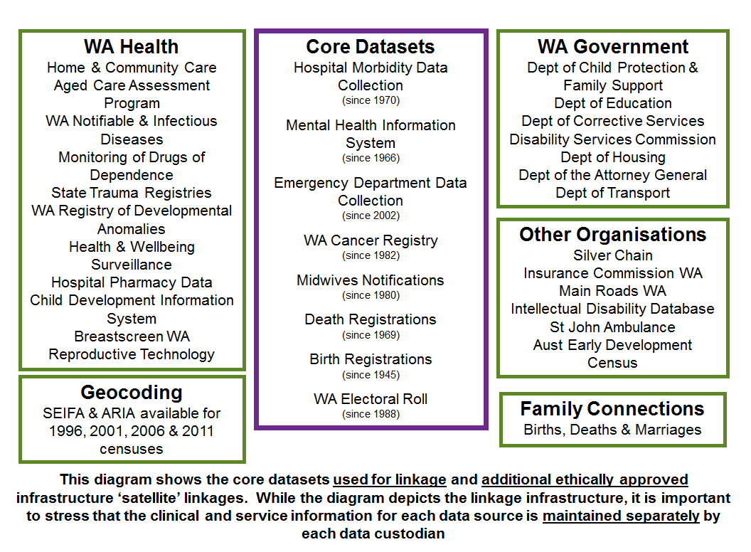
Figure 1
Source: A Review of Western Australia’s Data Linkage Capabilities: Developing a Whole of Government Data Linkage Model, Data Linkage Expert Advisory Group, 2016

Until recently, our ability as researchers to access Commonwealth data was severely limited (ref Senate Select Committee on Health). This meant that our extensive and total population national health data sets (deaths, hospitalisations, registers of cancer, birth defects, disabilities and heart disease etc) were not able to be linked to the Pharmaceutical Benefits data of all prescriptions taken up. Other countries are envious that we have such information computerised and potentially linkable to detect the harmful effects of drugs and to ascertain whether drugs are being prescribed safely and appropriately. They are also curious as to why we have not done such linkage.
In the 1980s the awful story of thalidomide exposure in pregnancy causing major birth defects (babies born with severe arm and leg anomalies) hit the media. It resulted in total population birth defects registers being established in many developed countries. FS and her team were the first such register funded in Australia, driven in part by the additional fear of the effects of Agent Orange spraying in Vietnam ³.
Despite significant lobbying over many years (PMSEIC document Data for Science 2006⁴; Stanley & Meslin MJA 2007⁵), data have only sporadically been made available to research teams to link and analyse. Australia has never been able to reassure its pregnant women that the next “thalidomide” will be discovered quickly and damage avoided. As our consumer groups have said “ to have such data which could improve the health system, avoid tragedies and deaths and not to use it, is reprehensible” (Anne McKenzie, Head – Consumer and Community Health Research Network, UWA.)
In 2016, the Prime Minister and Cabinet released a paper entitled Public Sector Data Management which reflected a radical change in culture and focus⁶. Workshops were held with Federal bureaucrats to which researchers from around Australia were invited, along with ABS, AIHW amongst others. In 2017, the Treasurer Scott Morrison commissioned the Productivity Commission to investigate Data Availability and Use. Their report made many quite bold recommendations⁷. Here is a telling quote: “Lack of trust by both data custodians and users in existing data access processes and protections and numerous hurdles to sharing and releasing data are choking the use and value of Australia’s data”. “Recommended reforms are aimed at moving from a system based on risk aversion and avoidance to one based on transparency and confidence in data processes, treating data as an asset and not a threat.” (PC 2017). The Hon Angus Taylor, the then Assistant Minister for Cities and Digital Transformation was supportive of the opening up and sharing of Commonwealth data and he interviewed one of us (FS) for a Tech Talk, on the power of linked data)⁸. This makes the case for health data linkage and addresses the privacy issues around data sharing.
The PM&C convened a small round-table with the Department of Health in April 2018 (co-chaired by David Gruen) with researchers, experts in data linkage, some state based data linkage personnel, and some senior staff from AIHW. At this stage, we confined our discussion to linking health data sets as a proof of principle activity towards a national pharmaco-vigilance capacity as exists in Canada and mentioned earlier. Further larger meetings are planned to take this forward. Subsequently, the researchers have formed RADiANT⁹ (Australian Real World Data Network) which is a national network of researchers who are expert in linking and using existing agency data at both state and federal level. In addition to providing expert input in to any future plans and how best to implement the Productivity Commission report, this group aims to work closely with bureaucrats to analyse data together and to build capacity within the APS. In addition, they are interested in using eHealth records and other big data sets to research population patterns and potential pathways to aid in policy and practice development and evaluation.
The announcement in the May budget was positive in relation to the Productivity Commission report. Funding has been committed and most of the main recommendations agreed to.
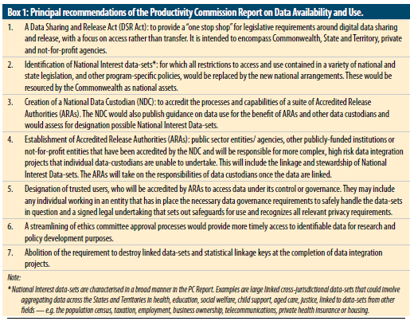
Figure 2
Source: ANZPH Journal Article⁷
It is important that the data custodians not be involved in making decisions about sharing and releasing of their data sets once all other proper processes and procedures for data sharing are in place (see recommendations). To leave decision making with custodians once data are in a secure and data linked repository with no identifiers will delay these important secondary uses of data and replicate the situations which have caused such data access and use delays in the past. We also recommend that the Accredited Data Authorities be independent of government.
We also recommend that there is a time line and ongoing budget for this important activity.
The Western Australian experience over 35 years of data linkage of population data sets is a model of best practice (Holman, et al^{10,} Stanley et al¹¹) as are Ontario and Manitoba in Canada (Henry et al 2018¹²). This latter paper describes the experience in Canada and compares this to the potential for Australia. It is a blueprint for us to follow as we are more like Canada than the Scandinavian countries who also have a long history of data linkage, based on each individual having a unique identifier from birth.
Australian states and territories are well placed to use the Commonwealth data as since 2009 we have funded the Population Health Research Network (PHRN¹³), via an NCRIS grant. This has resulted in all states and territories now having the capacity developed in Western Australia many years ago. Whilst your terms of reference include the APS “acquiring and maintaining the necessary skills and expertise”, there is no doubt that the best way to move the linkage and use of data forward is for the APS to team up with the considerable researcher expertise that exists in the states and territories, within ABS and AIHW and other centres and institutes (and now networked in RADiANT). Such experts can both analyse data with the APS and also train them in the demanding skills such analysis demands. This could form the basis for a national initiative as in the recommendations below.
- Recommendations:
- Implement the major recommendations of the Productivity Review in relation to data access and use;
- That PM&C and all APS agencies commit to a reasonable time line and appropriate budget to implement the Productivity Review recommendations.
- That the ongoing process to develop this set of activities builds in a strong consumer and community voice, with power to influence the ways in which data are accessed and used.
- Funding for access and linkage of data sets and the infrastructure and governance should come from government (Federal and state/territory) and not from precious and scarce research funds. The latter can be used to fund research projects which use linked data.
- A long-term vision for an Institute of Evidence Based Policy (such as Toronto ICES or Manitoba Centre for Health Policy) be developed for Australia. This should be a devolved model bringing in the considerable research expertise in the states (in Institutes, Universities, Centres) and evidence based policies within state/territory governments, to be part of a hub and spoke model. Whilst AIHW exists, it would need considerable changes to convert it to a national model as suggested here, as it concentrates on health and welfare data.
- Accredited data authorities be independent of government, while collaborating closely with both the Commonwealth and State governments. The independent centres in Manitoba and Ontario provide models for establishment and governance of such centres.
- That the responsibilities of Commonwealth data custodians to approve sharing and secondary use of data cease once the data have been shared through a secure mechanism and have been linked and de-identified by the Accredited Data Authority. Other appropriate bodies who are expert on the science, privacy issues and ethics should decide who can access such data.
- That the APS implement the recommendations from the Indigenous Data Sovereignty communique and work with First Nations academics across all areas to better engage with a first nations voice.
- References:
    - Walker J, Lovett R, Kukutai T, Jones C, Henry D. Indigenous health data and the path to healing. The Lancet (2017): https://doi.org/10.1016/S0140-6736(17)32755-1
    - Indigenous Data Sovereignty Communique June 2018: http://www.aigi.com.au/wp-content/uploads/2018/07/Communique-Indigenous-Data-Sovereignty-Summit.pdf
    - Western Australian Registry of Developmental Anomalies (WARDA) http://healthywa.wa.gov.au/Articles/U_Z/Western-Australian-Register-of-Developmental-Anomalies
    - Working Group on Data for Science Report to PMSEIC: From Data to Wisdom: Pathways to Successful Data Management for Australian Science (2006) https://archive.industry.gov.au/science/PMSEIC/PMSEICMeetings/Pages/SixteenthMeeting-8December2006.aspx
    - MJA Article, FJ Stanley & E Meslin. Australia Needs a better system of healthcare evaluation. https://www.mja.com.au/journal/2007/186/5/australia-needs-better-system-health-care-evaluation
    - Prime Minister and Cabinet paper: Public Sector Data Management: https://www.pmc.gov.au/resource-centre/public-data/public-sector-data-management-report
    - Productivity Commission investigation into Data Availability and Use Report, released 2017: https://www.pc.gov.au/inquiries/completed/data-access/report
    - Tech Talk with Angus Taylor MP: https://ministers.pmc.gov.au/taylor/2017/tech-talk-professor-fiona-stanley-ac
    - RADiaNT: https://radiant.med.unsw.edu.au/
    - Holman CD, Bass AJ, Rosman DL, Smith MB, Semmens JB, Glasson EJ, Brook EL, Trutwein B, Rouse IL, Watson CR, de Klerk NH, Stanley FJ. A decade of data linkage in Western Australia: strategic design, applications and benefits of the WA data linkage system. Australian Health Review 2008;32(4):766-77. https://www.ncbi.nlm.nih.gov/pubmed?cmd=Retrieve&list_uids=18980573&dopt=Abstract
    - Stanley FJ, Glauert G, McKenzie AE, O’Donnell M. Can joined-up data lead to joined-up thinking? The Western Australian Developmental Pathways Project. Healthcare Policy 2011;6(special issue):63-73. https://www.ncbi.nlm.nih.gov/pubmed/24933374
    - Henry D et al: Access to routinely collected data for population health research: experiences in Canada and Australia. ANZJPH 2018 doi:10.1111/1753-6405.12813 (in press)
    - Population Health Research Network: http://www.phrn.org.au/

