APS Review
Submission by APS Indigenous SES Steering Committee
July 2018

Introduction
To be effective, governments must work across organisational boundaries to develop well-informed, comprehensive policy advice and implement policies in an integrated way. The evidence indicates that high performing organisations are those that have a diverse workforce and that this further drives innovation and productivity.
Critical to this diversity dividend is the government’s ability to understand and facilitate both social and economic opportunities for Indigenous Australians. The more Indigenous people employed in the APS, the more our policies and programs will reflect Indigenous worldviews, needs and aspirations.
To achieve this, the APS needs to develop a critical mass of Indigenous employees across the workforce. This goes beyond just numbers, and includes representation across the APS classification levels and across agencies.
Given the relatively high level of social and economic disadvantage faced by many Indigenous individuals, families and communities, it is imperative Indigenous people are active participants in shaping, designing and implementing policy. This will require not only Indigenous parity, but also strong representation at the executive and senior executive levels of government.
Current Indigenous representation in the APS
Indigenous employees currently represent 3.3 per cent of the APS workforce (December 2017). This represents employment parity for Indigenous people in the APS. Figure 1 below highlights the improvement in Indigenous representation over the last 10 years.
Figure 1. APS Employees
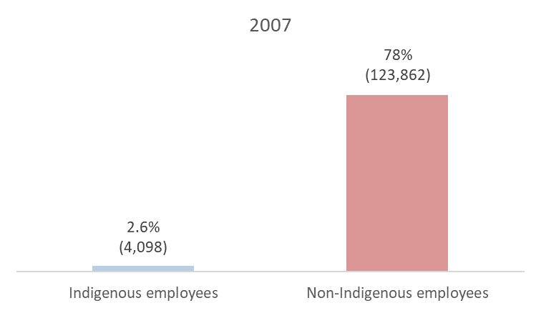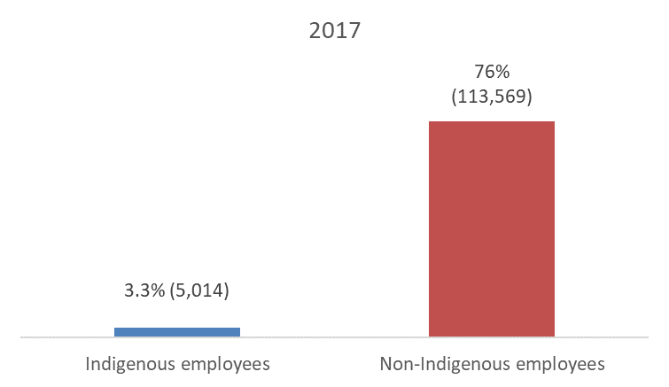

The Indigenous age profile is skewed towards the younger age group, so over time, the level of Indigenous representation in the population will increase. Therefore, unless Indigenous people are recruited and/or retained at a greater rate than non-Indigenous people, the goal of future employment parity will not be achieved.
How do we attract more Indigenous people to work in the APS without relying on entry-level recruitment?
The APS develop a more robust, frequent and transparent reporting of Indigenous participation in the APS.
Develop more a more engaging, exciting, promotional material and narrative, including for delivery in the schooling systems. Use existing Indigenous staff in promotional material, highlighting the diversity of roles available and the stories of Indigenous staff.
While employment parity is commendable, Indigenous people remain compressed within the lower classifications. Figure 2 below highlights the discrepancy in employment profiles for Indigenous versus non-Indigenous people. Further, the data shows that, despite the government’s commitment and many strategies to raise the Indigenous profile over time, the discrepancy has increased over the last 10 years.
Figure 2. APS Employee Profile
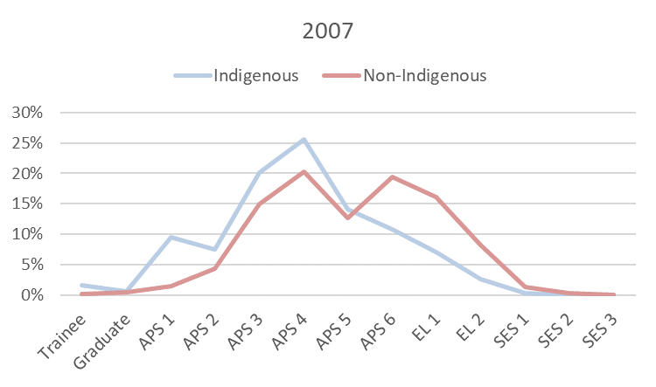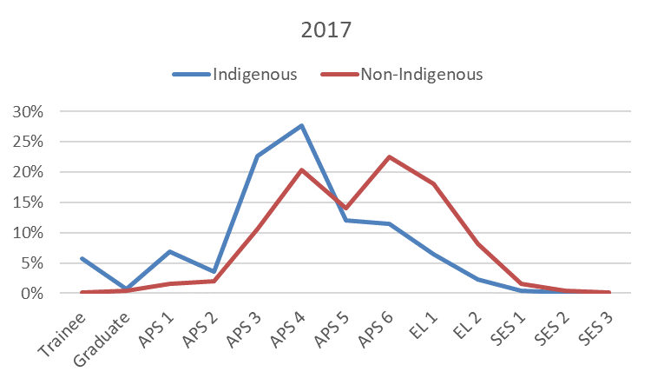
The amplified discrepancy has emerged due to the recent (last 3–4 years) accelerated focus on entry level recruitment for Indigenous people compared to non-Indigenous people. For example, 86.6 per cent of Aboriginal and Torres Strait Islanders were engaged at or below the APS 4 level in 2016–17 compared to 57.1 per cent of non-Indigenous people. The above graphs also highlight the lack of progression from the APS 4 level; in fact, the APS 4 cohort has grown, and has only shown incremental growth occurring at the APS 6 level.
What is the APS narrative to attract young aspiring future Indigenous leaders in a very competitive employer market? The Indigenous SES Network Steering Committee recommends a refocus from “serving the community” to “nation building”.
There has been a steady decline in the proportion of Indigenous employees at the APS 5–6 classifications across the APS. At its highest point in 2011, 27 per cent of Indigenous staff in the APS were employed at the APS 5–6 classifications. This figure has now dropped to 23.4 per cent at December 2017, in contrast the proportion of non-Indigenous APS 5–6 employees is 36.4 per cent.
The number and proportion of Indigenous staff at the Executive Level is also declining. Over the last 10 years, the proportion of Indigenous staff in the APS employed at the Executive Level classifications has fallen from a peak in 2011 at 12.5 per cent to 8.7 per cent. Over the same period, the proportion of non-Indigenous employees at the Executive Level has remained relatively constant, and is now at 26.3 per cent.
At the SES level, the discrepancy is larger, with 25 Indigenous SES officers compared to 2,326 non-Indigenous SES officers (1%). Furthermore, this discrepancy has continued over the last ten years as evident from figure 3 below.
Figure 3. SES Employee Profile
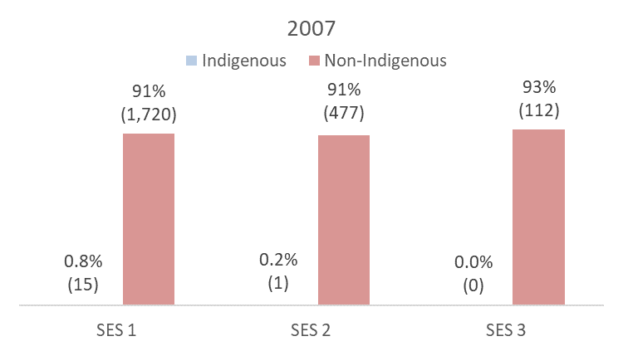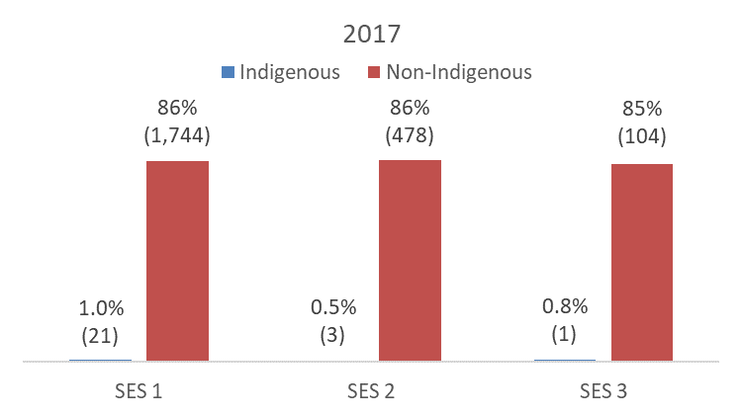
How can the APS drive significant reform to increase the number of Indigenous people employed at the executive level and senior executive level?
What other sectors are leading the way in attracting and retaining Indigenous employees and executive, and can we learn from them?
Consider incentives to encourage the behavioural change amongst APS leadership.
APS leaders need to provide a greater authorising environment for SES staff to do the same.
Can we look at an option of excluding Indigenous SES numbers from the SES cap for small to mid-size agencies?
Improving the quality of Leadership and Development of high potential Indigenous staff. This may include identified development pathways. (This potentially could be developed by a strengthened APSC unit).
Career Progression
APSED (APS Employment Database) data shows that Indigenous employees accounted for 3.1 per cent of all promotions during 2016-17. While this figure is close to parity, almost half (49.9 per cent) of promotions of Indigenous employees were at or below the APS 4 classification compared to 19.1 per cent for APS wide.
As a recruitment strategy to employ Indigenous people, Affirmative measure—Indigenous employment is used. Can this recruitment strategy be used more broadly to maximise its effectiveness?
What are the opportunities to explore greater mobility of employees across the government and non-government sector?
Develop Indigenous Employment targets that better reflect areas-of-need for improvement, such as under-representation in the employee classification profile and spread across the various portfolios. An overall single percentage target is not precise enough to drive behaviour to where it is needed e.g. if the current target can met by expanding entry-level programs—what incentive is there to change?
Length of Service
The median length of service for Indigenous employees is 7 years. This is 4 years lower than the APS wide median length of service of 11 years. This discrepancy is partly the result of the recent acceleration of Indigenous entry-level recruitment.
Changing nature of work in the APS
Over the last ten years, the work of the APS has changed dramatically due to advances in technology, increased utilisation of the service sector as a delivery arm for government and inter-government agreements that have transferred functions to the state governments.
As a result, there is a greater focus on policy development and reduced opportunities for service delivery. This shift in focus has a greater impact on Indigenous employees who are located outside of Canberra; the hub of policy development, as figure 4 demonstrates.
Figure 4. APS Employee Location
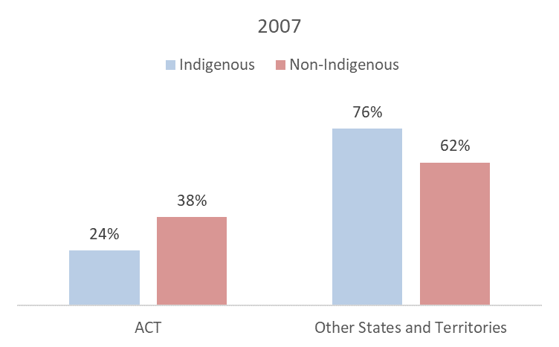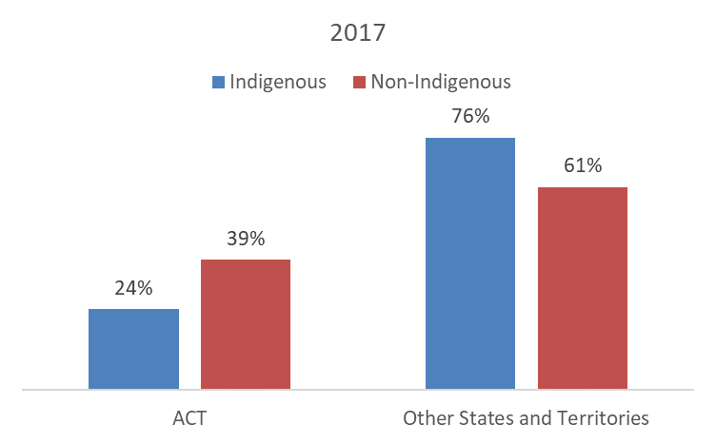
How does the government most effectively engage with its workforce given that the demographics show that the majority of positons are outside of Canberra?
Given that Indigenous people are represented at a regional level—how do we make them a central platform for policy? How do we support a regional presence?
Consideration should be given to the skill sets of future Indigenous students at secondary and tertiary levels to meet the changing skills required in the APS.
Furthermore, the proportion of Indigenous employees working in front line service delivery positions (generally with lower APS classifications) is higher than non-Indigenous employees. As a result, Indigenous employees are more likely to have their employment and career prospects adversely impacted by outsourcing and technology advancements (such as self-help apps). For example, 42 per cent of Indigenous employees are employed in the Department of Human Services, Department of Home Affairs and the National Disability Insurance Agency, agencies with a focus on service delivery.
What development opportunities are required to ensure Indigenous employees are equipped with the skills needed for the future work of the APS?
The APS is increasingly a blended workforce (contractors and labour hire). While this is also the case for many other sectors, Indigenous employees highly value the level of employment security offered by the APS—69.3 per cent of Indigenous respondents to the 2017 APS employee census are satisfied with the “stability and security” of their current job. This security is a point of difference for the APS, and in a competitive market for Indigenous talent, reductions in security will likely result in a deterioration in Indigenous numbers, proportions and profiles.
How can the APS raise its profile as a great place to work for Indigenous people and reduce the reliance on tenure?
We also need to simplify the process of staff to move between agencies—this is essential to broadening capability, diversity and skills.

Indigenous reference incorporates Aboriginal and Torres Strait Islander people.
Note: Data has been omitted for employees that have chosen not to disclose their Indigenous status. As such, percentages may not total 100 per cent on certain graphs throughout this paper.
2017 APS employee census, per cent of Indigenous respondents that agree or strongly agree.

