Submission
to
Independent Review of the Australian Public Service

Organisation: Melbourne School of Government
Address: Level 2, Walter Boas Building
The University of Melbourne, Parkville, Victoria, 3010, Australia
Contact: Professor John Howe, Director

- Melbourne School of Government submission to APS Review

  - Melbourne School of Government, based at the University of Melbourne, is a tri-faculty institution drawing together expertise from across the disciplines of economics, law, management, international relation, business and public policy. We seek to develop interdisciplinary solutions to the contemporary challenges of governing Australia and the region. The School thanks the Independent Review Panel for the opportunity to make a submission to the Australian Public Service (APS) Review.
  - Staff at the University of Melbourne and Melbourne School of Government are happy to elaborate on any aspect of this submission should the Panel find this helpful.

- Executive Summary

  - The capability and strength of the APS is built upon its characteristics. By this, we mean the culture of the organisation; the qualities of its workforce; the skills and knowledge of public servants; and, the reputation of the Public Service in the community. These will all need to be carefully stewarded throughout this Review and its recommendations to ensure that Australia retains a vibrant and effective Public Service. The characteristics of the APS are underpinned by its values, impartiality; commitment to service; accountability; respect; and, its ethics. These values should inform the introduction of an integrated workforce development framework that is essential to the success of strengthening the capabilities of the APS.

- Culture

  - We see the fostering of a ‘one APS’ culture as a key focus of the Review; where colleagues work as though they are part of a single organisation delivering the best outcomes for Australians, in place of prioritisation of loyalty to the department and the outputs of that portfolio. An APS that acts together in concert across a broad range of activities will be difficult to achieve, but there are enormous potential benefits to encouraging joined up outcomes, particularly as policy problems become more interconnected and dependent on the efforts of multiple actors. A ‘one APS’ culture reflects the need to ensure the APS remains driven by the needs and concerns of the community. The New Zealand State Services Commission has emphasised this in its recent ‘Spirit of Service’ program through a focus on the collective responsibility of public servants to improve outcomes of New Zealanders, as opposed to the deliverables of individual ministers and departments. Careful consideration should be given to ensure that the private and public benefits accrued from a more joined-up APS are evenly distributed throughout the community.
  - Ideally, the achievement of a ‘one APS’ culture should go beyond the ad hoc introduction of cross-departmental teams for limited periods of time. As in New Zealand, this may require a significant change in thinking on the part of senior leaders in the APS and may have implications for a Cabinet system designed around ministerial portfolios and individual responsibility. The Review could consider recommending the introduction of cross-APS initiatives to support the development of an organisation wide culture. This institutional underpinning would connect officials across the departments and executive agencies of the APS, possibly focusing on the professions of the service, including: policy advice; major projects; operational delivery; and human resources.
  - There is scope to bring together public officials working in these pan-APS professions and use them as a focal point for the introduction of an integrated workforce development framework. Examples of these initiatives can be found in the 2012 UK Civil Service Reform Plan with the introduction of Major Projects Leadership Academy, the Civil Service Leadership Academy and the strengthening of Professions with the Service. In the UK, all civil servants working on Major Projects undergo a similar pathway, permitting the acquisition of commercial and contracting skills; an understanding of policy design that carefully considers the demands of implementation; and, gives them experiences on a range of projects in more junior roles before being appointed to lead more significant projects. These professions signal clear career trajectories for public officials and acts as a focal point for conversations between senior managers and more junior colleagues, supporting the use of a common vocabulary across the service.
  - The Review could consider going further and recommend the rotation of public servants through core elements of the APS. Future leaders, graduates and those seeking to progress through a profession could systematically be placed in a number of departments, engaged in a variety of positions, across a range of geographic localities, to fully embed the idea of a ‘one APS’. This will ensure that aspiring leaders and valued specialist staff are exposed to the methods and priorities of a number of departments and agencies, and would be a light touch way of organically supporting the development a ‘one APS’ culture.
  - By way of example, the UK Civil Service Fast Stream channels graduates into broad schemes, such as, finance; project delivery; commercial; and, generalist, which require rotation through several departments and executive agencies over the two-four year schemes. Whilst civil servants will settle into a department after finishing the scheme; there is a requirement to rotate through various parts of the Civil Service before graduating from the Fast Stream. In this, colleagues gain an understanding of the varying roles of civil servants across several different locations in the UK. Towards senior levels, the UK Civil Service signalled a commitment “to move over time towards a position where there is a more equal balance between those departmental Permanent Secretaries who have had a career primarily in operational management and those whose career has been primarily in policy advice and development”.
  - The emphasis on operational delivery expressed through the UK Fast Steam may not necessarily reflect the federal architecture of Australia. Perhaps further thought could be given to how best to support the development of policy advice talent in a system where the States and Territories are responsible for a significant proportion of the delivery of government services. The Review could explore the recommendation of the inclusion of rotations through different aspects of the APS outside policy advice, and possibly within appropriate state and territory public services. APS colleagues could gain vital experience by understanding how state and territory colleagues deliver federal policy initiatives. This would enhance the idea of ‘one public service’ delivering for the best community outcomes. Further research could be undertaken to fully understand the challenges and opportunities that the APS would face in engaging with the states and territories in this way.

  - Fostering innovation in the APS
    - The APS by its very nature is a continually reflective organisation that must respond to the changing demands of the community. It will be important for the Review to focus on the challenges the APS needs to meet in understanding community perceptions, requirements and reactions to the changing policy landscape that Australia is expected to face in 2030. The APS should carefully blend future horizon work (elaborated on below) alongside stronger engagement with the community, business groups and universities to ensure that innovation is introduced at a pace and scale that is appropriate to Australia.
    - The APS needs to do more to develop clear mechanisms for fostering innovation to ensure that policy solutions remain relevant and draw on the best evidence available. According to a recent survey, only 50% of APS staff ‘implemented innovations in the past 12 months’. The use of policy labs and other forms of co-production has yielded some success in international comparator countries by bringing together important stakeholders at the outset of policy design. There could be a key role for research institutions built into a strategic framework for engaging with preferred providers in this space. For example, the Blavatnik School of Government at Oxford University have been working with the UK Civil Service on the co-development of effective social impact bonds and outcomes based commissioning as part of a $10million program.
    - Such initiatives could support an APS that should seek to foster a work culture that encourages higher risk tolerance amongst officials. The APS has an undeniable role in curating policy advice and should use this position to become a distiller of inputs from a variety of external organisations, whilst retaining the important internal capacity to provide fiercely independent guidance to ministers. Further work is needed to fully assess the policy capacity of the APS across the service, but also within given domains (defence, health, financial regulation etc.) to assess any capacity gaps, but also to communicate needs to strategic partners.

- Workforce

  - The quality of public servants in Australia is what makes the APS one of the leading organisations of its kind in the world. However, more remains to be done to make working in the Public Service worthwhile and rewarding to ensure the APS attracts and retains the most talented Australians possible. The ‘2017 APS Attitudes at a Glance’ found that 67% of public officials found a feeling of personal accomplishment in their work, leaving room for improvement.

  - Professional Development Tracks
    - We suggest that the Panel consider recommending the introduction of Professional Tracks which encourage mobility of public officials between departments; between the private sector and the public service; and, geographically. This is important to ensure that public servants are given clear signals for potential career pathways and understand that the successful public servants will need a focused set of skills gained across a broader range of postings. Professional Tracks will mandate a learning journey for public officials to guide them through their career development. These could include placements in operational delivery, policy implementation, ministerial offices and policy advice to give public servants the opportunity to apply their skills across the whole of the public service. The Tracks would require a breadth of APS postings, alongside the acquisition of formal learning, to enable progression through the APS and could be introduced to create a pipeline of talent in areas of emerging importance. Formal learning opportunities based in universities and other providers can ensure that public servants gain recognised qualifications as they progress through their Track. These could include a Master of Public Administration at the University of Melbourne, a Master of Public Policy with a policy specialisation from Australia National University or an interdisciplinary science graduate course at another provider. Qualifications can be used as stretch assignments to permit the acquisition of knowledge alongside the application of skills in a variety of rotating postings.
    - Professional Tracks could include a dedicated Leadership Track (elaborated on below), but also create pathways for colleagues aiming to specialise in policy advice; major projects; community engagement; or, evaluation. Through the introduction of clear professional tracks, the APS has the opportunity to become a lifelong learning organisation by emphasising first-hand knowledge of wider activities of the APS alongside applied formal learning opportunities. This mobility must be implemented appropriately to strike a balance between maintaining the retention of corporate memory in key positions, and ensuring that any change does not become counter-productive.

  - Leadership Track

    - The identification and nurturing of future leaders of the APS will be critical for its ongoing success. The introduction of a Leadership Track deserves special mention to ensure that the APS has the right people leading it in 2030. The APS needs a track that encourages the acquisition and application of commercial and contracting skills; policy advice; project implementation; and, external experience (in private enterprise, academia or community organisations) for the development of the senior officials of the 2030s.
    - As above, this should be matched with the opportunity for micro-credentialisation of formal qualifications throughout the learning journey to permit the acquisition of specialised qualifications from strategic service providers. This will be necessary to permit the transfer of skills and knowledge between the public and private sectors, which will be important in facilitating public servants to move in and out of the APS. Examples of this include the UK NHS’ Nye Bevan Programme and award in Executive Healthcare Leadership, whereby aspiring directors blend work-based study, online learning and residential workshops to support their career development. The primary goal of these programmes should be to support officials working through complex networks in areas of joint accountabilities.

  - Diversity and Flexibility

    - To govern the Australia of 2030, the Public Service must be more like the Australia of 2030. The APS has made great strides in increasing diversity within its ranks, but more can be achieved so that the sum of the talents of the community can be brought to bear against the grand challenges that will face the nation over the next decade. More work needs to be done to increase the attraction and retention of Australians with disabilities, Australian’s from indigenous communities and Australian’s from non-English speaking backgrounds. These groups of colleagues are currently underrepresented relative to their numbers in the community to the point where only 3% of the APS workforce are people with disabilities, compared to the 14% of working age Australians.
    - To support the inclusion of more Australians from a non-English speaking background, consideration should also be given to relaxing the ‘general expectation’ that public servants will be Australian citizens to work in the APS to reflect the reality that not all members of the community can acquire dual citizenship. Existing Diversity Workplace Programs could be strengthened and pivoted to place a greater emphasis on supporting under-represented groups of Australians into APS roles.
    - Historically, the concept of the APS as a model employer has strong resonance in Australian public sector employment practices and regulation. These include wage and non-wage terms and conditions of employment (such as protection against dismissal and flexible working arrangements) and dispute resolution mechanisms for public sector employees. It will be important throughout this Review to ensure these practices are sustained as the APS seeks to retain and attract the most talented Australians. Fostering a culture that encourages the transfer of talent between departments; between the APS and state/territory services; and, between the public and private sectors, will require the APS to retain its pre-eminent position as one of the best employers in Australia. This could in part be achieved through the decentralisation of public service roles, from Canberra. 37.9% of the APS is based in Canberra, with an even greater concentration of SES roles in the capital city. By locating more significant parts of the APS in state capitals and across regional Australia, the APS can better facilitate the transfer of talent between and into the Service, particularly from the private sector. The Review could consider commissioning research into the recruitment and retention strategies needed by the APS to support a workforce that is comfortable transitioning between multiple sectors, multiple times throughout their careers, whilst maintaining the workplace conditions that allow the APS to lead the community on employment practices.

- Skills

  - The APS needs to ensure that the public servants of 2030 are given the opportunity to acquire the skills and knowledge demanded by the future challenges Australia faces. These opportunities could be delivered through an integrated workforce development framework by a set of preferred strategic partners.
  - In both the acquisition of context-specific knowledge and the development of subject matter expertise, the APS can provide structured opportunities for on-the-job duties that permit the application of newly gained skills alongside the attainment of knowledge through a formal qualifications provider. These tracks need not be mutually exclusive and should permit the attainment of leadership, subject matter and context-specific skills over the course of a career.
  - This integrated workforce development framework would clearly articulate career tracks to the APS workforce and permit the creation of a strategic framework for the APS to help determine the roles of providers like the Crawford School of Public Policy, the Melbourne School of Government and the Australia New Zealand School of Government. By setting out the requirements of APS through the integrated workforce development framework, strategic partnerships for future research and teaching and learning provision can be developed with preferred providers.
  - To foster the idea of a ‘one APS’ culture, consideration should also be given to the introduction of a foundational level of knowledge and skills for all public servants. This should be acquired by public servants upon commencement of their positions within this APS and should cover the APS Values, Employment Principles and the agenda of the Government of the day. This could be achieved by developing a strategic framework with preferred providers who then deliver a series of massive online open courses (MOOCs) which provide a consistent and APS-wide level of understanding and a common vocabulary for entry-level positions.
  - This baseline knowledge could be enhanced for graduate-entry roles, future leaders and senior levels by further engagement with preferred providers to reaffirm this common vocabulary. Any provision for such a baseline should carefully reflect the need for a ‘one APS’ culture and the specific needs of individual departments.
  - Building upon a standardised baseline understanding of APS values and principles, the development of context-specific knowledge and skills will be critical to the success of the APS in 2030. As with other suggestions, this could be incorporated into an integrated workforce development framework with strategic partners. Insights from future horizon work; the analysis of impending challenges and opportunities for Australia, should inform the identification of this context-specific knowledge and skills, so APS colleagues remain at the leading edge of policy development.
  - Well defined career tracks within the integrated workforce development framework could ensure that those seeking to work in specific policy domains (health, education etc.) can access context-specific knowledge and training that exposes them to – contemporary issues, challenges and drivers, underpinning legislative framework, global best practice and understanding of historical policy development approaches and lessons learnt. An APS that fosters these skills in its staff and is able to readily facilitate access to resources that inform their work will better address challenges arising from Machinery of Government changes as well as staff turnover.
  - Alongside the strengthening of context-specific knowledge with the Public Service, there are a number of emerging areas of knowledge which the future APS workforce will need to be across. The introduction of Subject Matter Expertise (SME) tracks within an integrated workforce development framework will enable APS staff to build expertise in a chosen area such as; big data and governance; artificial intelligence; or, science for policymaking. APS staff hoping to acquire SME status in this area should be able to access training on a range of topics which reflect new insights and knowledge. There is scope to draw on the expertise of leading research institutions such as the Melbourne School of Government, the Crawford School of Public Policy, and the Institute of Governance and Policy Analysis to support the strengthening of subject matter expertise.
  - Topics for further training in a ‘big data and governance’ SME track might include– data environments, metadata, statistical expertise, data biases, data provenance, data integrity, data analysis approaches, using data for policy design, ethical frameworks around data use and application. Further work could be commissioned to map topics in potential areas of subject matter expertise.

- Roles and Providers

  - An integrated professional development framework which builds upon the above professional tracks; the acquisition of subject matter expertise; and, which fosters the development of leadership skills through clearly articulated pathways, will enable the APS to then review existing provisions and providers. This review will facilitate the identification of future providers and empower the APS to communicate its strategic needs. The absence of such a professional development framework in these areas means that almost all providers are working in a fragmented, reactive manner. This hampers both specialisation efforts and the opportunity to build critical mass and expertise in specific areas at certain providers. The APS has an opportunity to facilitate the creation of centres of expertise across Australia for public servants to rotate through depending on their stage of career and area of focus. International examples include the Executive Master of Public Policy offered by the London School of Economics and Political Science (LSE) to members of the UK Civil Service. This degree is only available to civil servants ‘enrolled’ in the Policy Profession Track and has supported the creation of a leading school of public policy at the LSE.
  - This framework would need to be appropriately designed to involve an appropriate mix of providers, taking into account geographic spread and the need for a diverse range of skills and educational backgrounds of future public servants. This framework can foster distinct concentrations of expertise, but from across a broad range of providers, ensuring that the APS recruits the best and brightest from a wider range of Australia’s educational providers. In designing this framework, the APS will need to fully understand the impact on the role of the APS Commissioner and science agencies as it may overlap with some of their existing responsibilities.

Example ‘Major Projects’ Professional Track
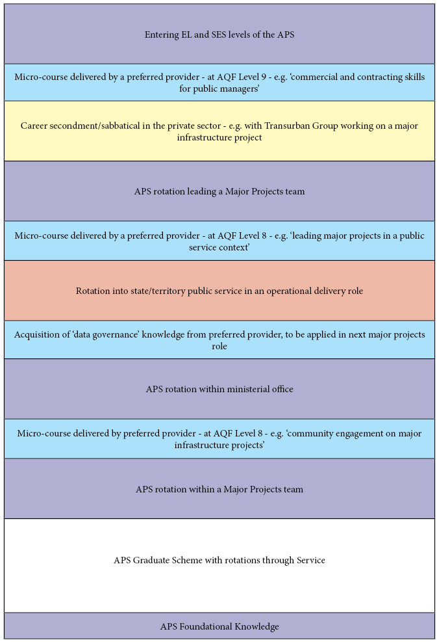
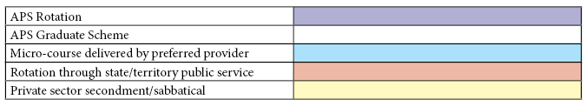

https://www.beehive.govt.nz/sites/default/files/2017-12/State%20Services%20Commission%20-%20Briefing%20to%20the%20Incoming%20Government.PDF
https://www.gov.uk/government/publications/civil-service-reform-plan
https://www.faststream.gov.uk/generalist/
https://stateoftheservice.apsc.gov.au/2017/10/2017-aps-attitudes-glance/
https://golab.bsg.ox.ac.uk/
https://stateoftheservice.apsc.gov.au/2017/10/2017-aps-attitudes-glance/
https://civilservicelearning.civilservice.gov.uk/sites/default/files/link_3_-_policy_skills_knowledge_-_curriculum_map_with_cpd.pdf
https://www.leadershipacademy.nhs.uk/programmes/nye-bevan-programme/bevan-programme-structure/
https://www.apsc.gov.au/trends-representation
http://www.abs.gov.au/ausstats/abs@.nsf/0/C7C72D7706E9BED0CA257DE2000BDC60?Opendocument
https://www.apsc.gov.au/fact-sheet-10-frequently-asked-questions
8 of the top 20 graduate employers in Australia are part of the Federal Government - https://gradaustralia.com.au/top-100-employers
https://apsc.govcms.gov.au/location-and-regional-staff
https://www.apsc.gov.au/strengthening-values-based-culture-plan-integrating-aps-values-way-we-work
http://www.lse.ac.uk/school-of-public-policy/Assets/Documents/EMPP-Brochure.pdf

