Submission to the Independent Review of the Australian Public Service

University of Melbourne
Australian National Development Index (ANDI) Limited
31 July 2018

Mike Salvaris
Fiona Stanley AC
Barry McGaw AO

1. Summary of submission
This submission is made by the University of Melbourne (UoM) and Australian National Development Index Limited (ANDI), a not-for-profit public corporation, with member organisations from many diverse community sectors. UoM and ANDI are partners in a major national project to develop ongoing new measures of Australia’s progress based on community engagement and research.
The submission proposes that the UoM-ANDI project could provide a valuable model for the Inquiry in four of its key focus areas: 1) delivering high quality policy advice, regulatory oversight, programs and services; 2) tackling complex, multi-sectoral challenges in collaboration with the community, business and citizens; 3) improving citizens’ experience of government and delivering fair outcomes for them; 4) improving how the APS monitors and measures its performance and ensures the transparent and most effective use of taxpayers’ money in delivering outcomes.

2. The ANDI project: measuring the Australia we want
The University and ANDI Ltd have entered a long-term agreement to develop an ongoing national index of Australia’s progress, wellbeing and sustainability. ANDI will measure progress in twelve progress ‘domains’ across all key areas of Australian society - economic, social, cultural, environmental and democratic.
The project will produce each year an aggregate index of progress and wellbeing, and indices and status reports in each of the twelve domains. Domain indices and reports will each be released in a different month, to maximise publicity and national discussion. Progress will be measured in twelve key goals or ‘sub-domains’ in each domain, as determined and weighted by community priorities and expert evaluation, and benchmarked against targets set (where possible) by a national or international best practice standard recognised as feasible and relevant for Australia.
The index will be developed in three phases, the first two being concurrent:
- a 2-3-year national community engagement program aimed to engage Australians across the nation in addressing the question ‘What kind of Australia do we want?’ The program will use a wide range of community engagement platforms and processes: see sec 5 below;
- an extensive national research collaboration led by the University of Melbourne, but engaging other universities and research centres with expertise in specific domains;
- a detailed focus on the application and optimal use of the ANDI tool and the community engagement processes it develops, and in particular, its impacts for: stronger democracy; improved public policy, planning and evaluation; better media reporting; and more informed public debate and understanding concerning Australia’s progress and future development.

3. Issues and context: a global movement
The ANDI project has been an active and long-term participant in a global movement to develop new measures of societal progress ‘beyond GDP’ which has grown over the past 20 years. Led internationally by the OECD Global Project on Statistics, Knowledge and Society, the Stiglitz, Sen, Fitoussi Commission on the Measurement of Economic Performance and Social Progress (commissioned by the President of France) and more recently, the UN Sustainable Development Goals program, this movement has drawn on earlier work from many diverse sources, including: the Club of Rome; the women’s movement; the community indicators movement; the ‘Triple Bottom line’ concept in business; and pioneering national projects such as the Canadian Index of Wellbeing, Bhutan’s Gross National Happiness Index and the Australian Bureau of Statistics ABS’s Measures of Australia’s Progress’ (MAP) project.
The central premise of the global project is that GDP is an inadequate measure of societal progress, despite its general acceptance (though with steadily growing reservations) as an indicator of aggregate economic activity. It is now broadly agreed that GDP fails to measure many important economic activities (such as unpaid domestic work and the added value of, for example, public health and education); that it counts as a positive the sales of many products (tobacco etc) which are harmful; and it increases with natural disasters such as wars, bushfires and floods. GDP does not measure the wellbeing of the population (and was not intended to, by its principal inventor, Simon Kuznets), yet continues to be used as the dominant national benchmark of success for governments in most nations.
Under the OECD’s leadership, and through a process of regular global conferences and regional workshops initiated in 2004, many countries have worked together to change how they define and measure the progress and wellbeing of their societies, and to develop new measures to guide them to invest in policies which will result in more equitable and sustainable communities in the future.
The key underlying questions raised in this process are profound and of universal relevance, in Australia and elsewhere:
- Is an economically productive society necessarily a happy one?
- What does ‘progress’ mean to the world’s citizens?
- Which environmental, social and economic indicators should be included in the measurement of quality of life?
- Why is there a gap between the effects of current measurement of wellbeing and the real lives of citizens?
- Why (and how) should citizens be engaged in developing new measures of progress for societies?
- How can these new progress measures guide the practical processes of government budgets, policymaking and national planning?

4. Implications for public policy
Over more than a decade of deliberation, some clear lessons and conclusions have emerged from the OECD-led global movement. Initially embodied in the international ‘Istanbul Declaration’ (2009) and gradually built on in subsequent OECD World Forums, these lessons have direct relevance for the improvement of public policy, in Australia and elsewhere. They can be summarised as follows:
- The indicators that a nation adopts to measure its progress and guide its policymaking will directly affect the well-being and life-chances of its people. The wrong measures will produce adverse consequences for policy and wellbeing.
- GDP is essentially a measure of economic output and not societal well-being, and using it as the main measure of society's progress has contributed to environmental and social problems (such as inequality and environmental degradation) and poor policy. New measures are needed which reflect a more holistic and balanced vision of equitable and sustainable wellbeing: they should include (at least) the social, economic, cultural, democratic and environmental dimensions of progress, and both objective and subjective measures of wellbeing and quality of life (such as life satisfaction, security etc).
- The task of developing these new measures is ultimately a democratic one and must engage communities in working with policymakers and scientists. The process of citizen engagement in developing new progress goals and measures is not only necessary in itself (because of its impact on wellbeing) but it can also be an important way to renew democracy and re-engage citizens at a time when in many countries, democracy is in decline and citizen trust is low.
- The key challenge ultimately is to build these new progress measures and community permanently into government policy-making and community awareness. Fully developed, they can enhance democracy, strengthen government transparency and accountability, improve national planning and help develop a shared national vision.
Collectively, these issues present both a great challenge but also an extraordinary opportunity for the public policy and leadership of a nation pondering its future in times of global and regional uncertainty. As OECD Secretary General Angel Gurria put it:
We are facing both an opportunity and a duty to rethink what progress really means and to build stronger and more inclusive visions for the future of our societies. Citizens are looking for new ways to improve their lives. We need committed citizens, scientists and well-informed leaders ready to engage the whole of society in an assessment of the challenges ahead. Adequate measurements are essential in helping our societies to define their goals; ensure that we design the right policies to achieve them; and tell us whether those policies are working.
The central question here and now is ‘What kind of Australia do we want?’ If we are to answer this question in ways that enhance both our public policy and our democracy, the key will surely be not just addressing ‘the citizens’ experience of government’ (considered as ‘customers’) but their active engagement in it (as participants, stakeholders and trustees). This last is an area in which there is presently at least as much need for ‘agility and innovation’ – and new ‘dedicated’ processes - as there is in more traditional public sector management practice.
As the European Union has said
Civil society, together with the other social and institutional players, should determine the arenas in which the progress of societies is to be gauged, identifying specific areas and salient facts in the economic, social and environmental spheres. This can only be done by means of dedicated information, consultation and participation instruments.
If the government seeks to ‘(tackle) complex, multi-sectoral challenges in collaboration with the community, business and citizens’, then it could perhaps start by re-appraising the potential for a more engaged Australian democracy, and new forms of collaboration between government and civil society, in which citizens are encouraged to be active and to fill a variety of roles beyond that of increasingly passive customers. One innovative and nationally significant example of active citizen engagement in data management and progress measurement in recent times is the Indigenous Data Sovereignty Movement.

5. ANDI’s development model
In the first stage of the project over the past 18 months, the ANDI project has piloted the index development in two key domains (health and education); carried out a national survey of key progress and wellbeing issues and priorities; piloted a national community engagement program; and developed a long-term research and funding program. The various stages in the overall development of the pilot process are set out in Figure 1 below.

Figure 1: The ANDI Pilot Process

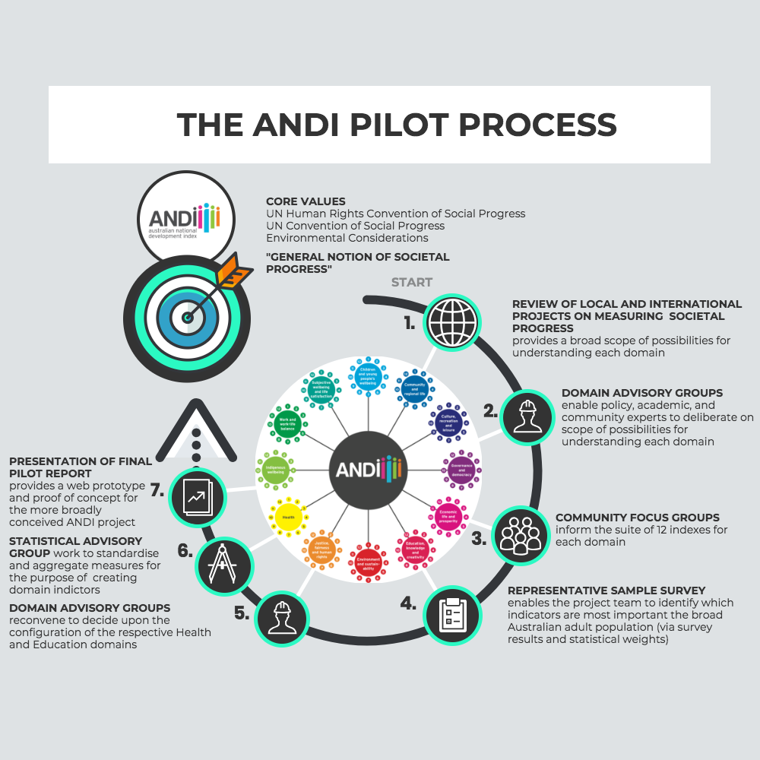

Over the next 5 years, the project will carry out a large-scale national community engagement program and fully develop its overall index and twelve progress domains and indices, gradually enlarging the number of the project’s community partners, research collaborators and funders. The long-term aim is to develop an enduring framework for discussing, defining, measuring and promoting national progress that is a world leader, incorporates best practice from the OECD and other national models, and has high levels of public trust and policy utility.

Community engagement innovations
As indicated earlier, ANDI, in common with other leading international projects (such as the Canadian Index of Wellbeing and the Welsh government’s ‘The Wales We Want National Conversation’) is using a 3-stage approach to developing better measures. The first stage is to have an ongoing conversation with Australians as to what they want their country to be for them. Various methods have been pilot tested and existing surveys used to see how best to ask the people for their views on what they value most about Australia.
For the full national community process, we are proposing to engage the Australian community as widely as possible in order to develop a shared vision of national progress, obtain direct input on goals and priorities, build legitimacy and trust for the index and in the process, strengthen Australian democracy.
This national program will be built around the central question ‘What kind of Australia do we want?’. It will be carried out over three years and will aim to directly involve 500,000 Australians through a wide array of platforms and programs: surveys, focus groups, town hall and kitchen table meetings, social media and blogs, school curricula, film and video. To support the program, ANDI will seek to enlist a major national media partner and will fully utilise the widespread networks of ANDI partners and their two million members. The UNDP has agreed in principle to ANDI adapting its successful global survey MyWorld2015 as ANDI’s major interactive platform and we propose to adapt this for use with a Smart Phone App, thus increasing its likely attraction, especially for younger Australians. There will also be citizen and stakeholder engagement in each of the twelve ‘domain’ development groups.
ANDI aims to ensure that citizens’ voices help set the priorities across all areas of government. Asking a large and representative sample of Australians what they value and want from their governments for themselves, their families and their community (now and in the future) enhances democracy and will certainly ‘improve citizens’ experience of government’. These conversations will be ongoing, and this will mean that government can keep up with what the community is thinking in a rapidly changing society.
Even more importantly, in the longer term a successful program of this kind, provided it is transparent, inclusive and accessible to all, can help to re-build citizens’ confidence in government and democracy, directly enhance their citizenship skills and help create a shared national vision for Australia’s future.

Public policy benefits
ANDI is a potentially powerful vehicle for national planning and policy making.
For a nation, as for corporations and individuals, ‘true progress’ consists in moving towards clearly articulated goals, rather than simply producing more or doing better than last year. ANDI will aim to measure Australia’s ‘true progress’ against a set of concrete, community-validated goals and aspirations. The ANDI model has 12 domains, as illustrated in Figure 2 below. For each domain twelve clear goals or sub-domains will be identified (by the community and expert process indicated earlier) as those which are judged most important for national progress, each weighted for its perceived importance. Thus, taken as whole, the ANDI framework could be seen as a program for Australia’s future development, a concrete statement of the outcomes needed to achieve the kind of country that Australians want theirs to be.

Figure 2: ANDI’s twelve progress domains
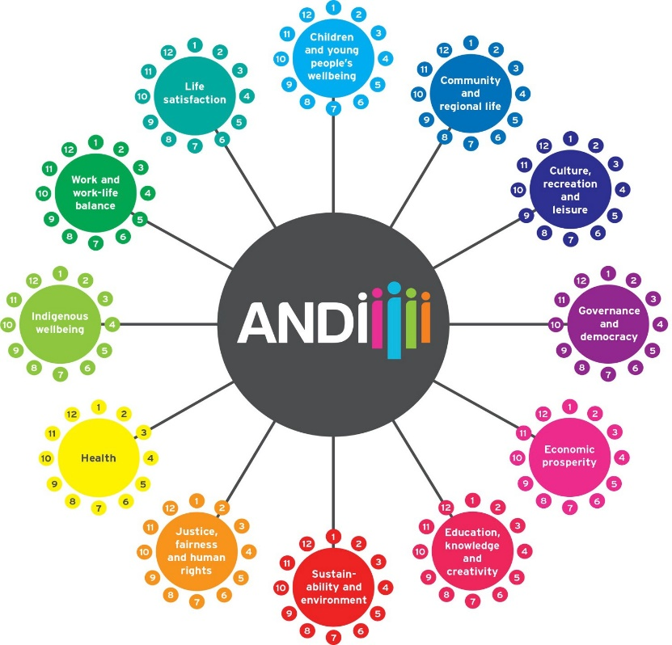
From another perspective, the ANDI framework will be a powerful policy diagnostic tool. When the Index is fully developed, using the ANDI domains and goals, policymakers and citizens will be able to interrogate what are the key areas driving success or failure in relation to Australia’s overall progress, both at the levels of the individual domains of progress and within each domain.
Given ANDI’s ‘12 x 12’ domains/sub-domains model, the Index can help guide policy change by identifying the areas that are most influential for wellbeing and progress. Going deeper into the sub-domains in each domain, it will be possible to tease out the pathways which need to be taken to achieve better outcomes. For example, in the pilot, we have seen, as others have, that our education progress measures are going backwards and that a key reason for this is inequity, lies with more poor and marginalised children dropping out of school prematurely. Hence it may be that these pathways need to have a greater investment by government than others. The same formula can be used in health, justice, the environment, etc. To make this complex information accessible and attractive, we are developing a graphic display platform that easily enables this ‘drilling down’ process, right down to the actual data or statistics used for key indicators.
Over time, ANDI’s unique approach (developing a ‘vision’ for Australia based on the values and goals for which the people ‘vote’ and measuring progress towards it) could help to move policy-making away from partisan decisions and endless debate about ‘the true facts’ – a situation which often leads to policies which are neither evidence-based nor particularly valued by the community. This outcome would have particular benefits for the Australian Public Service, in a key goal area of the present inquiry: ‘improving how the APS monitors and measures its performance and ensuring the transparent and most effective use of taxpayers’ money in delivering outcomes’.

International collaboration
An important component of ANDI’s five-year program with the University is the development of a major international collaboration, focused on the question: how should new progress measures be implemented and entrenched in government and international standards?
Prospective partners will include: The University of Rome 2 (a European leader in the development of national progress and sustainability measurement); the University of Waterloo (which hosts the Canadian Index of Wellbeing) and the OECD. Other partners currently being sought include the government of New Zealand, whose Prime Minister recently announced her intention to make New Zealand a world leader in building wellbeing into budgetary planning and the government of Wales, which has developed integrated legislation to entrench ‘the sustainable wellbeing of future generations’.
This collaboration is planned to be launched at the forthcoming OECD World Forum in November 2018 in South Korea. As a follow up, it is proposed that the next OECD World Forum (in 2020) should be held in Melbourne, with a focus on the practical implementation in government and bureaucracy of new societal progress and wellbeing measures including the SDG’s. Initial discussions have taken place with the Minister responsible for the OECD, Hon Julie Bishop.
The implementation of the SDG’s is one issue currently being considered by the Department of Foreign Affairs and Trade and on which DFAT has sought ANDI’s advice. It is suggested that other divisions of the APS would also benefit from participating in this collaborative project, with its direct focus on the practical use of new progress measures for better and more accountable and responsive government.

6. Conclusion
The principal purpose of this submission was to outline how ANDI could be used to improve the effectiveness and responsiveness of the Australian Public Service and the quality of Australian democracy generally.
In the process we have highlighted some significant challenges and benefits. Some of the challenges relate to processes, such as the need to develop more effective and authentic ways to engage the Australian community. Others relate to information and data, and how they are used in an era when ever-increasing amounts of data are available and there is greater need than ever for this data to be used wisely and in the public good.
We believe that the ANDI project when fully developed will align with the Inquiry’s key goals in the following respects:
- as an innovation in public policy and democracy, based on a powerful global movement led by the OECD and well-established best practice in other countries (Canada, Italy, Wales, Scotland etc);
- as a tool for defining and achieving solutions to complex multisectoral issues in collaboration with community, business and citizens;
- by developing new digital technology platforms to identify and monitor citizens’ priorities and aspirations and to set and measure the achievement of national goals;
- as a means to improve transparency, accountability, planning and policy evaluation;
- as a process to support collaboration with community, business and other sectors based on clarity of purpose, an agreed evidence base and a shared understanding of goals and progress;
- as a vehicle to engage citizens in a meaningful democratic task and substantially improve their experience of, and trust in, government at a time of declining trust in government.
We would be very pleased to provide any further information, or more detailed submissions, requested by the Inquiry.

7. Recommendations
- That the APS review panel investigate the methods used by ANDI to develop a set of diagnostic tools to guide effective policy decision making and to engage community voices. In particular, the review panel should consider how ANDI could help the APS in the areas of alignment suggested above.
- That the panel consider whether a partnership with, or support of, the ANDI project and its networks of expertise in research, policy and practice could help to meet the aims of public sector reform as outlined in the Scope of the Review and the capacity of the APS to ‘acquire and maintain the necessary skills and expertise to fulfil its responsibilities’.
- That the panel investigate the benefits of government sponsorship of the OECD World Forum in Melbourne in 2020 with the key themes indicated above.
- That the panel investigate and support the Indigenous Data Sovereignty Movement as a nationally significant example of community engagement and autonomy in data use and progress measurement.

8. References
Coyle, D. (2014) GDP: a brief but affectionate history. (Oxford: Princeton University Press)
Credit Suisse Research Institute (2018) ‘Should we still care about GDP?’. https://www.credit-suisse.com/articles/news-and.../should-we-still-care-about-gdp.html
Mazzucato, M. (2018) The value of everything: making and taking in the global economy. (London: Allen Lane-Penguin)
Pilling, D. (2017) The Growth Delusion: Wealth, poverty and the wellbeing of nations. London: Bloomsbury
Salvaris, M. (2013) ‘Measuring the kind of Australia we want: ANDI, the GDP and the global movement to redefine progress’. Australian Economic Review, March 2013 v 46 no 1.
Stiglitz, J., Sen, A, and Fitoussi, J-P. (2008) Report of the Commission on the Measurement of Economic Performance and Social Progress (Paris.

Appendices

Appendix A: More than customers: Citizens as partners in achieving public outcomes
Citizens are … | How? | Examples
Customers | Citizens are principal users and clients of public services and should be treated as valued customers by providers | Citizens’ charters for service standards (UK)
Owners and shareholders | Citizens are owners: through their taxes, they invest in public service and assets. They are shareholders too: through their votes, they elect the ‘boards of directors’ who govern | Community reps on public services and utilities boards.  Federal, state and local elections
Issue framers | As ‘vision builders’: helping define desirable future, strategic plans. As advisers on government policy committees etc. | Community indicator projects (USA, Canada etc.); community advisory groups
Co-producers of services | Citizens and community bodies are direct providers of community services on both a paid and voluntary basis, in cooperation with government | Non-government community services. ‘Healthy cities program.
Service quality evaluators | As primary users of government services, citizens are best placed to assess their quality and effectiveness | Service user assessment forms. Students interviewing park users.
Independent auditors | Grassroots measurement by citizen groups is more likely to be independent and oriented towards actual community wellbeing outcomes | Citizen environment monitoring
(Epstein, P., Wray, L. et al. 2000. Engaging Citizens in Achieving Results that Matter: A Model for Effective 21st Century Governance. Minneapolis, Minnesota: Citizens League)

Appendix B: The spectrum of public engagement
Increasing level of public impact ►►
INFORM | CONSULT | INVOLVE | COLLABORATE | EMPOWER
Objective | Objective | Objective | Objective | Objective
To provide the public with balanced and objective information to assist them in understanding the problem, alternatives, or solutions | To obtain public feedback on analysis, alternatives, or decisions | To work directly with the public throughout the process to ensure that public and private concerns are consistently understood and considered | To partner with the public in each aspect of the decision including the development of alternatives and the identification of the preferred solution | To place final decision making in the hands of the public
Source: NSW Department of Infrastructure, Planning and Natural Resources website,
http://www.iplan.nsw.gov.au/engagement/essentials/spectrum.php Based on the original model of the International Association for Public Participation (IAP2)

Senior Research Fellow, University of Melbourne, Director, ANDI Limited
Distinguished Professor, University of WA, Co-Director, ANDI Project, University of Melbourne
Emeritus Professor, University of Melbourne, Co-Director, ANDI Project, University of Melbourne
For details of ANDI and its goals, members etc., see: www.andi.org.au
These domains are listed in Figure 2 below.
Stiglitz et al (2008)
For an overview of the global movement and ANDI’s development, see Salvaris (2013).
In 21st century economies, shaped by the combined effects of globalisation, high technology, a shift from production of goods to services, large scale financialisation, and artificial tax-related international transfers of income and wealth, the reliability of the mid-20th-century-developed GDP is increasingly questioned: see Stiglitz et al (2008); Coyle (2014), Credit Suisse (2018), Pilling (2017), Mazzucato (2018)
Coyle (2014)
For the Istanbul Declaration, see http://www.oecd.org/site/worldforum06/istanbulworldforum-measuringandfosteringtheprogressofsocieties.htm; and see generally Stiglitz et al (2008); Salvaris (2013).
The Economist Democracy Index 2017 in an article headed ‘The democracy recession’ highlighted a ‘broad based deterioration’ in many established democracies in recent years. These included: ‘declining popular participation in elections and politics; weaknesses in the functioning of government; declining trust in institutions; dwindling appeal of mainstream representative parties; the growing influence of unelected, unaccountable institutions and expert bodies; a widening gap between political elites and electorates; a decline in media freedoms; and the erosion of civil liberties, including curbs on free speech’. All of these problems have been identified in Australia: see, for example (1) http://www.abc.net.au/news/2014-08-11/poll-data-reveals-waning-interest-in-politics/5662568 (reporting recent ANU and other research findings) (2) the Scanlon Foundation-Monash University, Social Cohesion Report 2017 (reporting declining levels of trust in political parties, government and even democracy itself, most worryingly amongst young Australians); (3) The Guardian (2017), ‘IMF says Australia has one of the fastest rising income inequality rates’ https://www.theguardian.com/business/2017/oct/12/imf-says-australia-has-one-of-the-fastest-rising-income-inequality-rates
3rd OECD World Forum on Statistics, Knowledge and Policy ‘Charting Progress, Building Visions, Improving Life’, Busan, South Korea, 27-30 October 2009
European Economic and Social Committee on GDP and Beyond, EU, 2012, p 3
Appendices A and B set out two prominent models illustrating (1) the broader roles that citizens can play in a well-governed democracy and (2) the potential for extending government-community collaboration.
See: www.aigi.com.au/wp.../07/Communique-Indigenous-Data-Sovereignty-Summit.pdf
www.ciw.ca
http://www.cynnalcymru.com/project/the-wales-we-want/
www.myworld2015/org
In the longer term, one possibility may be the development of an international system of ‘Social Accounts’ ‘equivalent to the influential UN System of National (Economic) Accounts (SNA), which provides the chief auspice for the GDP.
Note that a related submission on data linkage has been put to the Inquiry by Profs Fiona Stanley and David Henry, which also referred to the ANDI project (Prof Stanley is associated with both projects).

