SEEK SUBMISSION

INDEPENDENT REIVEW OF THE AUSTRALIAN PUBLIC SERVICE

1. The Future of Work

The Australian Public Service (APS) is operating in an increasingly complex environment. The ‘future of work’ is responding to digital disruption and automation, globalisation, changing demographics including a growing and aging population and an evolution in how people want to participate in work and manage their careers.

At SEEK we have looked closely at some of these major factors impacting the ‘future of work’. What is clear is that all organisations, including the APS, will need to think differently about how they attract and retain the talent they need to prosper into the future. This is critical for the betterment of their workplaces and employees, and the communities they serve.

**There is barely an organisation or function that will not be impacted by automation and artificial intelligence (AI)**

At SEEK we have looked at globally well-recognised studies on the likely impact of AI and automation technologies on labour and tried to apply them to an Australian labour market context. Our analysis has identified three domains we are continuing to explore:

1. We believe there will be accelerated hollowing out of the ‘middle’ of the labour market;
2. Demand for flexible working arrangements will also accelerate; and
3. New roles will emerge which will require large scale re-skilling.

SEEK has submitted to the Senate Select Committee on the Future of Work and Workers further detail on these three themes. We would welcome the opportunity to discuss these further with members of the Australian Public Service Review Panel.

These three domains have profound impact on how the APS needs to approach talent management for its various organisations. Further, these forces will impact the role that the APS plays in supporting policy outcomes for Australian citizens.

The Jobs and Innovation portfolio is not alone in the task of navigating this new world of work. The Education and Training; Home Affairs; Industry; Social Services; and Treasury portfolios all have a role to play. Indeed, the Australian Public Service Commission will also have a leading role; APS employees will be impacted by the same changes which will play out amongst the Australian labour force.

SEEK is ready to assist these and other agencies to navigate the above three major areas of change – and others that may be identified – to ensure they are positioned as employers of choice. Creating the right resources and developing the right capabilities to deliver on their policy and delivery objectives will be key for the APS. SEEK is well positioned to help with the APS’s most important resource – its people.

The future of Australia’s changing demographic

**As organisations direct their attention to attracting, retaining and developing talent with technological and digital skills, they must also maintain focus on creating and fostering diverse and inclusive workforces.**

Diverse and inclusive workforces that reflect the communities they serve deliver many benefits with the most prominent being:

* More capable of understanding and meeting the needs of customers;
* Adept at providing different ways of looking at work issues, driving innovation and boosting productivity; and
* Better placed to attract and retain talent[1].

**It is recognised by corporate Australia that there is a shortage of qualified and experienced candidates across various roles in technology and management. Because of this shortage, employers want to make themselves attractive to the widest range of candidates. They need technology solutions and training to identify and reduce conscious and unconscious bias in their talent sourcing process to build diverse teams.**

The modern economy is fast paced, and Australian citizens and businesses demand the services provided by the APS to keep up, so they can progress and prosper. On top of this the make-up of Australia is vastly different from what it was approximately 40 years ago when the structure, approach and operations of the APS were designed reflecting a framework for public administration shaped largely by the Coombs Royal Commission.

Australia's population is ageing; the representation of older people has increased progressively over the last century, from 4 per cent in 1901 to 14 per cent in 2010[2]. The cultural character of Australia is also evolving. Australia has become one of the most ethnically diverse countries in the world. In the 1996 Census, 23.3 per cent of the population was born overseas. By 2016, this had increased to 28.4 per cent[3].

Diversity in the workplace

For the APS to improve the experience and services they can offer the citizens and businesses of Australia a diverse workforce is paramount. Only through a diverse workforce will the APS be able to understand the opportunities and challenges Australian citizens and businesses face in a modern, digital economy and respond accordingly.

For many, when they think of workplace diversity, the first thing that comes to mind is ethnicity and gender, but diversity is much broader than that. Workplace diversity refers to a variety of differences between people within an organisation. This includes everything from cultural background and religion, to personality and education.

SEEK’s latest research revealed that the top three factors **working Australians** think are most important when it comes to workplace diversity are:

1. Experience (72 per cent);
2. Education (54 per cent): and
3. Personality type (33 per cent).

When SEEK asked **Australian Government** employees what is top of mind when thinking about diversity in the workplace, the responses were quite different:

1. Race/ethnicity (43 per cent);
2. Gender (17 per cent); and
3. Experience (12 per cent).

Through SEEK’s proprietary research we can help the APS meet the diversity expectations of the customers they serve, and their own workforces’ expectations.

**Reaching a broad population in the job advertising and talent sourcing process will be an essential consideration for the APS to attract and build workforces comprising of people with diverse work experience.**

SEEK is Australia’s most trusted career destination receiving over 35 million visits to our site every month. The sheer scale of our site enables us to deliver hirers the greatest diversity of talent compared to any other career destination.

By partnering with SEEK we can make it easy for the APS to quickly discover, select, and connect with relevant and ready candidates – both those actively searching, or just open to new job opportunities – providing the APS with exposure to the most diverse talent pools.

SEEK also invests in developing products to reduce bias in the hiring process to support the hiring of diverse workforces. An individual’s name can indicate both gender and ethnicity and, while it is not the only solution in overcoming unconscious bias and should be used with care, removing a job seeker’s name from their profile can go a long way to help reduce biased hiring decisions.

In early 2018 we launched new tool called ‘Hide Names’ which works to reduce unconscious bias in the hiring process. The feature, which is now available for all Talent Search and Premium Talent Search users on SEEK, helps reduce gender and racial bias by removing a candidate’s name from their profile, so hirers focus on merit, experience and skills.

We have also been conducting unconscious bias awareness training across Australia and New Zealand which many organisations have found useful as a first step in acknowledging we all have biases that inform our decisions and, we believe, a catalyst for them to more closely examine their recruitment processes.

Corporate Australia is leveraging the tools SEEK is developing. SEEK would like to work closely with the APS to leverage the technologies available to develop diverse and inclusive workforces.

1. Competing for Talent

The APS has two roles to play in the drive for innovation and improved economic productivity – innovating itself and being involved in economy-wide economic policy. Key to both objectives will be holding and developing leading employees at all levels.

The Australian Government makes up more than 25 per cent of the Australian economy[4]. Productivity growth in the Australian economy will falter if one quarter of it fails to innovate.

For the APS to respond to a digital Australia one of the biggest headwinds they face, along with all other Australian organisations, will be the lack of highly skilled workers required to support their transformations.

Highly skilled workers with capabilities and experience across science, technology and digital fields, as well as strong leadership and management, will be critical to enable the APS to deliver great service experiences to citizens that deliver on outcomes.

Australian workers perceive the government sector as one of the most secure sectors. SEEK’s data supports this, showing the sector has been a strong source of employment growth over the past decade. However, more than 50 per cent of all APS vacancies are listed on the *APSJobs* website only. This is useful for existing public servants and those who actively seek this out when looking to transition into the APS. Yet most workers in the private sector are unaware of the competitive jobs the APS has on offer.

Figure 1: SEEK New Job Ads over time, Government and Defence. Source: SEEK

As per Figure 1, SEEK data shows that Government is frequently hiring. The opportunity to work on projects and causes that positively impact society, competitive parental leave, job security, and other factors make the APS an attractive place to work. However, SEEK data shows that relative to the private sector, government roles receive less applications, minimising the talent pool to choose from.

Figure 2: Job Ad performance across critical ‘future’ roles. Source: SEEK

**Experience shows that poorly written job ads are the primary reason for low candidate applications on SEEK. For the APS to attract the talent required it must invest in partnering with industry experts to maximise the value and outcomes that are achieved in their talent acquisition efforts.**

Private organisations are maximising SEEK’s advisory services to get the best performance out of their job ads and talent sourcing. This includes job ad writing support to drive search and push recommendations of job ads to relevant candidates and pro-active candidate search tools. The result is private sector jobs across critical ‘future’ roles are being exposed to the widest candidate audience, delivering a strong and diverse application pool.

SEEK data show that across the APS there are roles where the salary bands are uncompetitive compared to the private sector. The tight salary bands to which the APS is bound highlights the importance for the APS to identify and understand their unique employee value proposition and invest in communicating this to job seekers.

***Figure 3: Comparing average advertised salaries on SEEK across key digital roles. Source: SEEK***

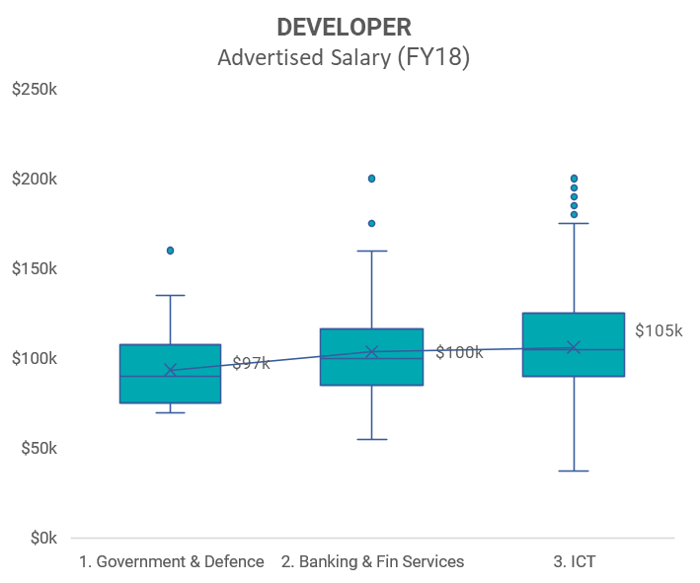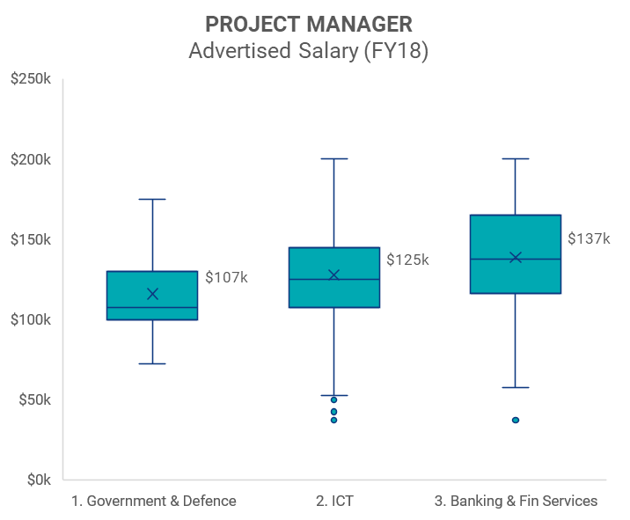

War of Talent

**There is not a large enough pool of highly skilled people to support Australian organisations as they transform to leverage digital technology. Over coming years, competition for this scarce, highly skilled talent will intensify further – creating a ‘war for talent’.**

Due to the long timeframes required to train highly skilled talent, the labour market will lag in addressing today’s shortages, and we expect these shortages to continue. Further to this, Australia will have less actual workers, and much higher worker to non-worker ratios as the population ages, as identified in successive Intergenerational Reports[5].

According to proprietary SEEK research only 30 per cent of the labour market is actively searching for opportunities at any point of time. The bulk of the remainder of the workforce is what we call ‘passive’ – they are open to opportunities if presented to them but not actively searching for opportunities. Add this to the previous statistic that only 50 per cent of APS opportunities are being presented via public recruitment channels and we see a significant percentage of the workforce without visibility of APS job opportunities. This compounds the challenges being presented by competitive, key skill labour shortages.

Immigration, chiefly skilled immigration, has been the classical solution in Australia to this challenge. However, with the highly-skilled segments of the labour market becoming increasingly globalised most developed nations are facing similar labour market issues as Australia. Added to this challenge is the requirement in much of the APS that employees be Australian citizens and, in cases for more sensitive employment, undergo rigorous security vetting.

The Private sector is responding to these challenges by being innovative in how they increase the reach of their opportunities and attract both active and passive candidates to apply. Investment in customised Employee Value Proposition (EVP) based on the employment drivers of those candidate segments and accessing proactive sourcing channels like SEEK’s Premium Talent Search to identify and proactively reach out to appropriate talent with the skills and experience to fill the critical roles available.

**In order to increase APS competitiveness in identifying and securing these key skills, the APS must see recruitment as a competitive business process and innovate, adopt new tools, and modernise business processes.**

We are aware of these challenges not just because of our role in the employment marketplace, but also first-hand as a hirer of leading tech-based talent. At SEEK we compete for a limited supply of highly skilled talent within Australia and across the globe, we understand the challenge the APS faces, and have data insights and tools to help position the APS to attract and retain this scarce talent pool.

SEEK has over 100,000 hirer relationships and more than 10 million jobseeker profiles in Australia. SEEK is well placed to assist the APS with its recruitment needs. SEEK offers more than job vacancy advertising. For example, we can provide services such as market mapping, which can show the APS where the required talent exists. SEEK has a wealth of experience assisting large employers – including various Australian governments – source and recruit talent.

1. Talent management and retention

The Australian Government is the single largest employer of Australian citizens. For the more than 150,000 Australians employed in the APS[6] and the thousands expected to apply for roles in the APS and other public-sector roles over the coming 20 years, the APS job application process will be one of the most crucial experiences these citizens will have with the Australian Government. However, our research shows that the application process for an APS role provides a great number of potential candidates with a negative experience.

Figure 4: Current Government and Defence jobseeker perceptions of job searching process. Source: SEEK.

Further, it is crucial for the ongoing creditability and value of the APS, and the principle of responsible and representative government itself, that the hiring processes of the APS are not only delivering fair outcomes but seen to be delivering fair outcomes for Australian citizens.

For hirers to position themselves to attract the most diverse and relevant workforce can require significant commitment of resources. SEEK is partnering with organisations offering technology and data driven solutions to increase efficiencies and outcomes in the search and matching of candidates to roles.

As a significant Australian employer, the APS can leverage review-based platforms to understand how they are seen by employees and address issues impacting their delivery of the employment brand promise. Company Reviews is an example of a marketplace platform which provides departments benchmark data on how they are perceived around key employment aspects such as salary, diversity and leadership.

Figure 5: Company reviews for Australian Public Service Commission. Source: SEEK.

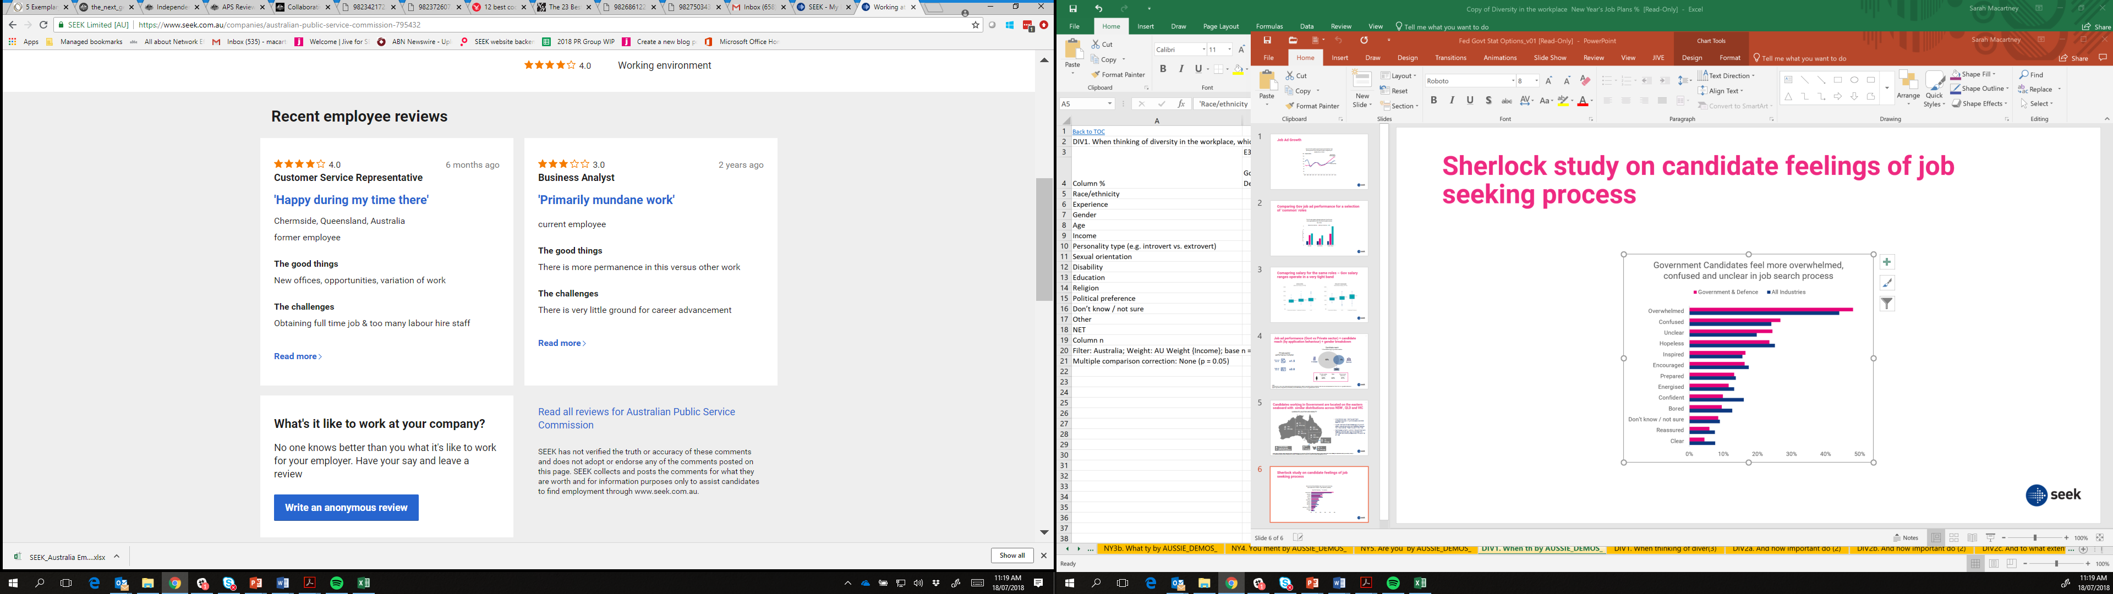

SEEK research shows[7]:

* Usage of online review sites when researching a company to potentially work for has grown since July 2015 (32 per cent to 42 per cent).
* Consulting personal connections such as friends/family, business networks or recruiters has declined, perhaps due to the increased reliance on company review sites.
* Among those who use online review sites, SEEK Company Reviews is the clear leader used by 71 per cent of people

The application and response experience are a part of the candidate experience that can deeply impact a candidates’ perception of an employer, and their likeliness to complete an application. Understanding the expectations of candidates goes a long way to establishing talent acquisition and management processes that reflect the APS employee value proposition.

Figure 6: Recognition of application, candidate expectations. Source: SEEK.

Life-long Learning

**Life-long learning needs to be supported by employers, including the APS. The skills and demands of the APS workforce will have to evolve in response to the environment in which it operates, and which will continue to change at a rapid pace.**

Shortages of highly skilled workers and the rising wages they will demand will create incentives and pressure for organisations to step-change how they train employees. This is a departure from how businesses effectively operate currently; relying on the education sector to train staff. Considerations the APS now face include:

* How do I help my staff acquire these skills to support the changing needs of our organisations?
* How do I retain and motivate those people, given they are likely to be highly desired by others?
* What level of investment can, or should I be making in an increasingly transient workforce?

**The APS cannot afford to simply rely on the workforce the education sector is producing; it must be more involved in training and developing its employees’ skills**.

**SEEK asked Australians how they plan to remain relevant to ensure that they continue to have a career in the next 10 years**, with results stating:

* On the job training (47 per cent);
* Staying on top of current information and trends (46 per cent);
* Further formal education (30 per cent); and
* Changing industry or looking at where their current skills might be utilised (24 per cent).

Soberingly, 22 per cent of people, nearly one in four working Australians, stated that they did not know how they could stay relevant.

SEEK can help the APS in the up-skilling and re-training of their workforce through connecting them to the relevant courses and qualifications so they remain relevant to the APS and broader workforce.

1. Delivering outcomes

Organisations of all sizes and industries across Australia are radically re-thinking how they approach talent sourcing and management. In a world where organisations must hire and retain the best people to support an increasingly competitive and fast-paced operating environment, engaging with the best talent sourcing and management partners is vital.

The complexity of the labour market makes it hard for organisations to succeed in talent sourcing and management on their own due to the customisation, dynamism and emerging nature of skill requirements that they must be across.

For SEEK to help people live more fulfilling working lives and help organisations succeed we pivoted our aspirations towards ‘placements’. Our placements target drives us to most effectively and efficiently connect candidates to highly relevant jobs, and hirers to highly relevant candidates. Our attention to performance, beyond job ad volume and candidate visits, is achieved through working closely with our customers to design and support the delivery of targeted talent sourcing strategies with a tight eye on reporting for performance.

SEEK is responsible for placing more Australians in work than any other employment marketplace.

Figure 7: SEEK share of employment placements in Australia. Source: SEEK



*.*

Some of the immediate opportunities we believe will drive performance and value for the APS in their talent sourcing and management are:

* Empowering recruitment/HR teams across Departments to leverage the information, training and tools available to them through SEEK is critical to allow them to operate to best-practice.
* Reviewing and mapping the APS Employer Value Proposition against talent sourcing needs.
  + SEEK has a wide range of behavioural data and market research that can be leveraged to understand current perceptions and candidate experience of the APS employer brand
  + SEEK Laws of Attraction research can feed into understanding the preferences, inhibitors, goals and aspirations that are key to customising messaging around the needs of the candidate segments, especially in talent short candidate markets.
* Apply best-practice to job ad writing
  + SEEKs’ breadth of job ad data can be leveraged to understand how the broader market is classifying roles and what appeals to candidates
  + SEEK can deliver training to the APS and Department HR/Recruitment teams as to what job titles are relevant to the target population they are hiring for
  + Job-Ad writing training will support the APS and Department HR/Recruitment teams to write ads that more compelling to job-seekers and ‘search friendly’ to improve job-ad views and market appeal
* Extend the distribution and reach of APS jobs
  + More than 50 per cent of APS jobs only go to *APSJobs* career site. This means these roles are cycling the same APS talent and missing the opportunity to compete for millions of Australians to better enable a more ‘modern and digital workforce’.
  + Engage in proactive sourcing to enable access to monitoring and passive candidates – only one third of the marketplace is actively searching for roles at any point in time. Tapping into passive candidates requires a more innovative and proactive approach to recruitment which is unfamiliar to the APS today.
  + As an example, only one department across the APS is using SEEK’s Premium Talent Search for proactive database search compared with 90 per cent of the country’s largest recruitment agencies and more than 50 per cent of large corporate recruiters.
* Better use of data and insights to monitor and drive performance

The APS is under-represented in their use of analytics platforms like ‘SEEK Analytics’, a free recruitment performance and insights tool, to plan and adapt recruitment activity.

1. Conclusion

The Future of Work is something we spend a lot of time at SEEK thinking about.

We have seen first hand how technology, digital disruption and demographic changes have impacted how we operate our business and respond to the market we operate in. We continue to invest to maintain and build on a workplace culture that is attractive to work for. We allocate substantial resources into building world-class products and technologies that respond to candidates and hirers needs to connect with employment and learning opportunities and great talent effectively and efficiently.

Our unique position as a technology company and Australia’s leading employment marketplace provide us with a sensitivity and understanding to support the APS as they reflect and prepare to act so to evolve to be an employer of choice and deliver on the services that are critical to the Australian economy.

We have outlined a number of ways in which we could work together and look forward to discussing this with you.

1. Stevens, F.G (2008). Unlocking the benefits of diversity – All inclusive multiculturalism and positive organisational change.
2. <https://aifs.gov.au/publications/families-australia-2011/demographic-and-social-change>
3. https://blog.id.com.au/2017/population/demographic-trends/australias-changing-ethnicity-a-preview-of-the-2016-census/
4. The Treasury, *Budget Paper No 1* (Commonwealth of Australia, Canberra, 8 May 2018) 11–16.
5. Commonwealth of Australia, *2015 Intergenerational Report: Australia in 2055*, (Canberra: The Treasury, 2015), 8.
6. Australian Public Service Commission, *State of the Service Report* (Commonwealth of Australia, Canberra, 3 November 2017), 5.
7. *Source: Independent research conducted by Survey Sampling International (SS)I on behalf of SEEK. Interviewing 4800 Australians annually with data being weighted to be nationally representative of age, gender, location, employment status and income (based on ABS).*