Independent Review of the Australian Public Service

A Consultation Summary Report
3 December 2018
___________________________________________________________________________

Introduction
In July 2018, the Independent Review of the Australian Pubic Service (the review) engaged Inside Policy to facilitate national consultations with Australian Public Service (APS) employees and members of the public.
The review examines whether the APS’s capability, culture and operating model are suited to harness the opportunities of a transformed Australian economy and society, in an increasingly complex global context.
This report provides a summary of the national consultation process and reflects back key insights we heard during consultation with APS employees and members of the public. It also identifies challenges for the future of the APS raised during consultations that the review may seek to resolve.

Project Overview
The Government announced the Independent review in May 2018. The Independent panel is led by Mr David Thodey AO, and joined by Ms Maile Carnegie, Professor Glyn Davis AC, Dr Gordon de Brouwer PSM, Belinda Hutchinson AM and Ms Alison Watkins.
The review is examining the capability, culture and operating model of the APS. It will make practical recommendations to ensure the APS is ready, over the coming decades, to best serve Australia in:
- delivering high quality policy advice, regulatory oversight, programs and services,
- tackling complex, multi-sectoral challenges in collaboration with the community, business and citizens,
- ensuring our domestic, foreign, trade and security interests are coordinated and well managed,
- improving citizens’ experience of government and delivering fair outcomes for them, and
- acquiring and maintaining the necessary skills and expertise to fulfil its responsibilities.
The review will report to the Prime Minister in the first half of 2019.

Who we spoke to
Over three months we spoke to 481 individuals who participated in 29 consultations held in 16 locations. This included 387 APS employees and 94 members of the public. Consultations focused on discovering participants’ perceptions of the APS, generating ideas on how to future-proof the APS and test emerging themes to arise from earlier consultations.
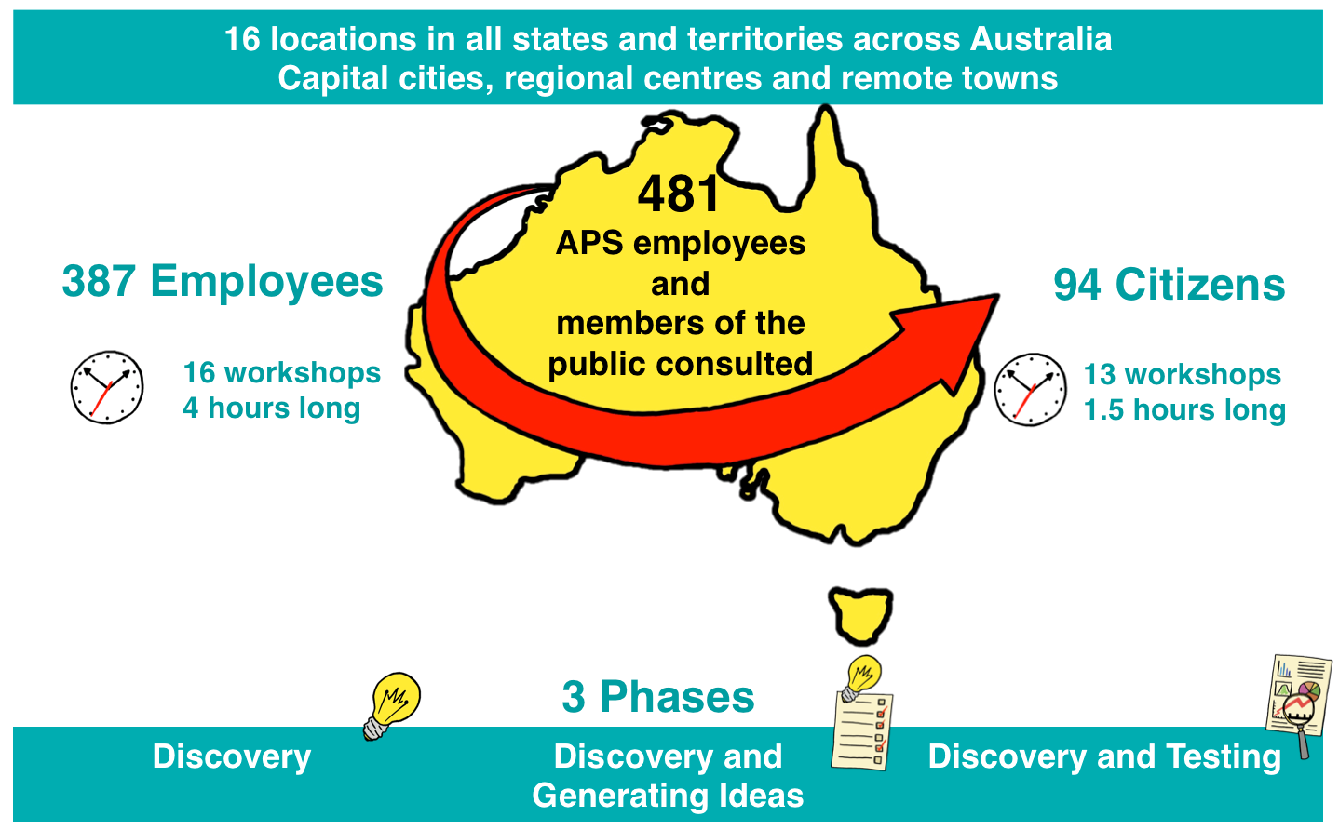

What we heard
APS employees and members of the public shared their views on the current state of the APS and expressed their vision for the future state of the APS. The five key shared aspirations people held for the APS are identified in the below graphic and discussed below:
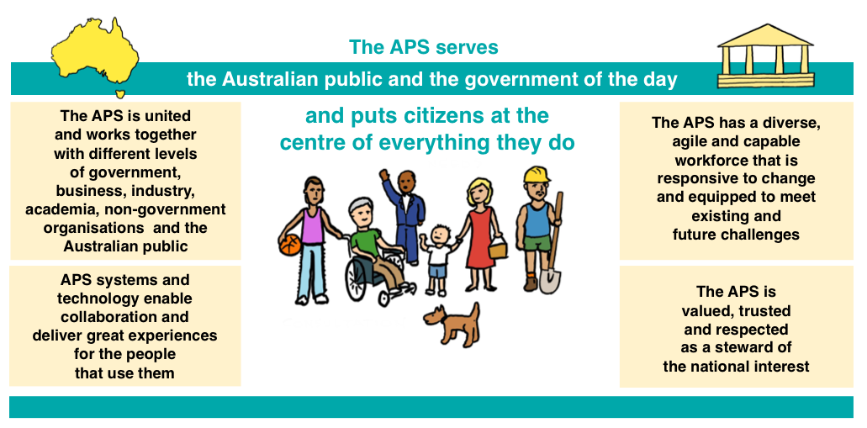
Each of the five themes contained in the graphic above are explained in detail below.
- The APS serves the Australian public and the government of the day and puts citizens at the centre of everything they do.
Overwhelmingly, we heard that the purpose of the APS is to serve both the Australian public and the government of the day. Employees identified service as both a core purpose and a value underpinning the work of the APS, stemming from the unique position the APS occupies as the only body in the country responsible for serving the public interest in an impartial and non-partisan way.
For many APS employees, serving the public and the government of the day was defined by being impartial, apolitical and developing and implementing future-focused and evidence-informed policy that understand the needs and experiences of citizens:
“If the APS doesn’t serve the public interest, who will?”
APS Employee workshop participant
Both employees and the public agreed that the APS has an important role to play in building a better Australia for all - including older Australians, Indigenous Australians, Australians with disability and other disadvantaged groups. This includes proactively identifying and resolving inequalities between different groups and importantly, between different locations. Participants from regional and remote locations frequently shared with us their frustrations about inequality in digital connectively and digital infrastructure between cities and the regions. As one participant in a regional town (only two and a half hours from a capital city) asked:
“How can we think about 2030 when the infrastructure and services
we currently receive are not even in 2018?”
Public workshop participant
Serving the public and the government was not only confined to policy development and implementation. It also extended to ensuring all Australians, including the most vulnerable in our community, have easy and equal access to systems, processes, supports and services that put the person first. There was a strong expectation that everyone (regardless of geography) should be able to access the services they need, when they need them, and in the way they choose. As one public workshop participant phrased it:
“Deliver services as if your customer had a choice.”
Public workshop participant
In particular, members of the public were clear and united in their call for more efficient, simple and convenient ways to engage with different government services and agencies. Developing a single point of contact for citizens or business (e.g. unified call centre or a ‘one- stop-shop’ service model) was frequently recommended. Some participants told us that this should include integrated systems, underpinned by a ‘milestone’ approach that would provide a more seamless, simple and equal experience for citizens:
“You shouldn’t have to seek government support, it should
come to you proactively, particularly at key life milestones.”
Public workshop participant

“When something happens in my life (e.g. birth or death), I should
only need to tell the government once.”
Public workshop participant

- The APS is united and works together with different levels of government, business, industry, academia, non-government organisations and the Australian public.
In all workshops, participants expected the APS to be united and collaborating both within the APS and with different levels of government, communities, academics, non-government organisations and industry. Both employees and members of the public told us that there is a need for a less siloed approach to policy development and service delivery and better communication and collaboration both in and outside the APS. We heard that there are many opportunities to improve policy development and service delivery through leveraging data, information and expertise:
“Collaboration makes us better off than competition.”
Public workshop participant
Both employees and members of the public identified a need for greater engagement with the public including through more place-based co-design processes, to better understand and design solutions that are tailored for individuals and communities. Members of the public felt the APS should do more to tap into citizen experience and use feedback to improve policies and services. Many members of the public also felt that the APS should be partnering more with different levels of government, the public, industry and business to reduce duplication and provide more efficient and effective services:
We need “a collaborative fabric” that “puts the right people in the room”.
Public workshop participant
Building One APS was considered one of the foundations upon which this will be achieved. APS employees told us that One APS will look like:
- A shared strategy (including purpose) across the APS.
- A brand and culture shift to promote the work of the APS.
- Standardised systems, policies and frameworks across the APS.
- One pay classification structure and set of workforce practices.
As an APS employee expressed:
“If we feel like we are on the same team, that’s a good place to start.”
APS employee workshop participant
- APS systems and technology enable collaboration and deliver great experiences for the people that use them.
All workshops elevated the importance of improving systems and technology to ensure they are fit for purpose and, simply, “can do the things people need them to do”.
Members of the public expected the APS to be already sharing data across departments and with other levels of government. While some people raised privacy or security concerns, overall we heard that sharing data was crucial to better experiences with agencies and services:
“APS should be sharing data, on the customer’s terms, to make a better service experience.” Public workshop participant
While we heard that the APS should continue improving its digital presence, maintaining a strong human element was equally important to members of the public, particularly during service delivery. Members of the public expressed a desire for flexible options in the way they engage with government agencies and services (i.e. people can choose whether to engage digitally online, via phone, or face-to-face):

“APS needs to keep up with the rate of technological advancement whilst keeping humanistic focus.”
APS employee workshop participant

“The APS is connected, walks in the citizen’s shoes and is not always digital by default.”
APS employee workshop participant
Participants suggested there be a focus on a unified communications, technology and data platform that serves the whole APS and enables collaboration, employee services and access to data.
The One APS concept was again raised as a key idea to improve digital infrastructure across the APS and to help create a seamless experience for customers. This related to building interconnected systems across the APS and providing seamless access to services and information to the public.

- The APS has a diverse, agile and capable workforce that is responsive to change and equipped to meet existing and future challenges.
In all workshops participants emphasised the importance of an APS workforce that reflects the diversity of the Australian people, is informed, flexible, responsive to change and capable of solving complex problems and delivering quality services.
Employees told us that building a culture within the APS that is proactive, future-focused, innovative and open to engaging in informed risk taking is central to creating a workforce that will be able to respond to existing and future challenges:
“The APS needs to move away from a fear of making decisions
and taking risks. In business, if you always get it right or are
always on budget then you’re not trying hard enough.”
APS employee workshop participant
Employees frequently expressed their vision for an APS workforce that values and invests in building internal expertise and capability rather than looking for outside expertise. It was suggested that creating opportunities for mobility within the APS and between the APS, private and NGO sectors was an effective way to build internal capability to address complex needs or problems. We also heard that it was important for employees to be offered challenging and interesting work to complement other identified benefits of working in the APS, including attractive pay and working conditions:
“I joined for a job, stayed because of the fulfilment each day –
started by chance, stayed by choice.”
APS employee workshop participant
Employees from regional and remote locations felt that a less Canberra-centric workforce and the de-centralisation of decision making were also critical to creating a more responsive workforce that is informed and empowered to act in the interests of the communities they serve:
“The APS should think national but have the agility to act local.”
Public workshop participant
The One APS concept was considered to be a foundation upon which a more agile and capable APS workforce will be achieved. Employees told us that they would like to see a more “liquid” workforce that would take a project-based response to issues and bring employees together from different agencies to solve more complex challenges. This should be underpinned by a focus on recruiting for core skills and competencies across the APS, a common pay classification and set of workforce practices, flatter structures and more individual autonomy and accountability for outcomes:
APS employees “should be accountable for outcomes, not hours.
APS employee workshop participant
- The APS is valued and trusted as a steward of the national interest.
The concept of the APS being a valued and trusted protector of the national interest resonated strongly with both employees and members of the public. There was a clear expectation that the APS leads and co-ordinates the protection and advancement of Australia’s economic, environmental, security, community and trade interests:
“The purpose of the APS is to facilitate the evolution of Australia.”
APS employee workshop participant
Employees overwhelmingly referred to the importance of the APS being valued and trusted for its expertise and capacity to deliver services for all Australians to ensuring the APS is able to fulfil its role as a protector and promoter of the national interest. Some employees felt that trust in the APS by the Australian people has declined in recent years and that it is critical that the APS reclaims this trust:
“Being trusted is essential if the APS is to fulfil its purpose.”
APS employee workshop participants
Both members of the public and employees agreed that developing evidence-based and apolitical policy as well as delivering services and interacting with the public in ways that are transparent, ethical and accountable are central to building public trust and confidence in the APS. We heard that there is a shared expectation that the APS will act as informed and informative leaders, helping citizens, agencies and business keep pace with change and anticipate the future.
The concept of a shared strategy and clearly communicated APS wide vison and purpose for advancing the national interest was again raised as an important foundation for ensuring the APS fulfils the expectation that it will be a steward of Australian places, values and interests and, more, broadly, our national narrative.

What will the APS look like in the future?
In the final seven APS employee workshops, participants considered five emerging themes identified from earlier consultation and engagement that describe the future state of the APS. Participants were invited to think about what each end-state meant to them, whether the language resonated and generate key ideas for achieving this end-state.
APS employees broadly agreed with the concepts underlying the five emerging themes of:
- United in a collective endeavour.
- World-class policy, regulatory and delivery performance.
- A trusted and respected partner.
- An employer of choice.
- Dynamic digital and adaptive systems and structures.
While the spirit and intent of these concepts resonated with participants, the language did not. All workshops that considered the themes suggested simplifying and using clearer language. The language of “An employer of choice” and “A trusted and respected partner” resonated most strongly with participants and were felt to clearly articulate what the APS should aim to look like in the future.
In contrast, participants found the language of “United in a collective endeavor,” “Dynamic, digital and adaptive systems and structures” and “World-class policy, regulatory and delivery performance” confusing and uncertain. Employees preferred language with clearer and more established meaning like One APS and felt the language should be more reflective of the importance of serving the Australian public and national interest rather than benchmarking Australia against other countries.
Employees interpreted each end-state as follows:

United in a collective endeavour.
- The purpose and outcomes to be achieved – this should be shared across the APS.
- The way the APS operates – collaboration and movement across agencies should be easier.
- The relationships the APS has with other levels of governments and the public – there should be shared objectives.
- Pursuing the “collective endeavor” of making Australia a better place.

World-class policy, regulatory and delivery performance.
- Relating to the core purpose of the APS – to develop and implement policy, regulate and deliver essential services in the Australian public interest.
- Work that is evidence-informed and driven by citizens’ needs (especially our most vulnerable citizens).

A trusted and respected partner.
- An essential end-state, but one that may not be realistic where the APS may be a regulator.
- This will have different meanings in different contexts and these must be explored (i.e. policy, regulation, funding and service delivery) and in different relationships (i.e. APS with the public, industry, other agencies, other governments, politicians). These different meanings should be explored.
- Partnerships with the public, industry, funded organisations and other levels of government as well as within the APS.
- Co-design, collaboration and higher levels of engagement with the public to achieve public trust.
- Building trust by being impartial and apolitical while also being transparent about decisions that are made by the APS.

An employer of choice.
- An APS where the most talented individuals in the country and the world want to work.

Dynamic, digital and adaptive systems and structures.
- Systems, structures and technologies that fit the purpose of the APS, now and into the future.
- Includes the internal systems, structures and technologies required to do APS business as well the external systems, structures and technologies required to deliver services, engage with stakeholders and communicate.
Key ideas for achieving these end-states all came back to the notion of the One APS – connecting across the APS, having standardised employment practices and systems across the APS and investing in the policy expertise of the APS. Employees also strongly felt that it was important to increase the independence of the APS in order for it to truly assert its place as a non-partisan policy advisor.

Challenges for the APS
The most significant challenges for the future of the APS identified from the consultations were:
- Holding a unique place but not being valued for this. The APS, having significant skills and experience, is primed to take a leadership role in public policy and citizen engagement yet participants perceive that the APS is not valued for these skills by the citizenry, politicians or the business sector.
- Serving the public interest versus the government interest. The desire of the APS to be citizen-centric and develop evidence-informed policy while also implementing the agenda of the government of the day particularly where that agenda was not addressing the needs of citizens or the national interest.
- Specialist versus generalist expertise. Balancing the desire to be a flexible and mobile workforce while maintaining sector and management expertise.
- Innovation versus responsible use of public resources. Balancing the desire to be a service that is “agile, empowered and risk taking” with the responsibility to be “efficient, transparent, probity driven and accountable”.
- Transforming the APS versus achieving expected resource and staff efficiencies. Implementing necessary changes to achieve a more agile, skilled and capable APS workforce in a context of ongoing reduction of APS resources, average staffing level caps and expected budget savings.
It is clear from the consultations that managing these tensions – and executing a transformation of the APS – will require an elegant mix of political will and leadership, legislative change and cultural change within the APS. The importance of all of these ingredients and complexity of navigating these tensions cannot be overstated.

https://www.apsreview.gov.au/about, date accessed 1 August 2018.
Ibid.

