Scenarios for 2030
A report for the Independent Review of the Australian Public Service (APS)
prepared by The Boston Consulting Group (BCG)

October 2018

Disclaimer

This report has been prepared for the APS Review Panel by the Boston Consulting Group (BCG). The APS Review Panel and Department of Prime Minister & Cabinet (PM&C) have been consulted in the preparation of this report, however, the views expressed in this report do not necessarily reflect the views of the APS Review Panel or PM&C.

The services and materials provided by The Boston Consulting Group (BCG) are subject to BCG's Standard Terms or such other agreement as may have been executed by BCG and the Commonwealth Government (the Client). BCG does not provide legal, accounting, or tax advice. The Commonwealth is responsible for obtaining independent advice concerning these matters. This advice may affect the guidance given by BCG. Further, BCG has made no undertaking to update these materials after the date hereof, notwithstanding that such information may become outdated or inaccurate.

The materials contained in this report are designed for the sole use of the Client and solely for the limited purposes described in the report. The materials shall not be copied or given to any person or entity other than the Client (Third Party) without the prior written consent of BCG. These materials serve only as the focus for discussion; they are incomplete without the accompanying oral commentary and may not be relied on as a stand-alone document. Further, Third Parties may not, and it is unreasonable for any Third Party to, rely on these materials for any purpose whatsoever. To the fullest extent permitted by law (and except to the extent otherwise agreed in a signed writing by BCG), BCG shall have no liability whatsoever to any Third Party, and any Third Party hereby waives any rights and claims it may have at any time against BCG with regard to the services, this presentation, or other materials, including the accuracy or completeness thereof. Receipt and review of this document shall be deemed agreement with and consideration for the foregoing.

BCG does not provide fairness opinions or valuations of market transactions, and these materials should not be relied on or construed as such. Further, the financial evaluations, projected market and financial information, and conclusions contained in these materials are based upon standard valuation methodologies, are not definitive forecasts, and are not guaranteed by BCG. BCG has used public and/or confidential data and assumptions provided to BCG by the Client. BCG has not independently verified the data and assumptions used in these analyses. Changes in the underlying data or operating assumptions will clearly impact the analyses and conclusions.

Contents
Contents 3
Summary 4
Introduction and Context 6
Approach 7
Megatrends 12
Theme 1: Changing expectations 12
Theme 2: Advances in technology 13
Theme 3: Societal and geo-political shifts 14
Theme 4: Changing nature of work 15
Scenarios 16
SCENARIO: #TECHSPLOSION 17
SCENARIO: DEVOLUTION REVOLUTION 21
SCENARIO: WIKIGOV 24
SCENARIO: NEW WORLD (DIS)ORDER 28
Common success factors 32
1: Alignment of limited resources to achieve greatest impact and optimise outcomes 32
2: Highly tailored policies and service delivery to individuals and local areas 35
3: Extensively using data and analytics for policy and service delivery, whilst protecting against the threat of cyber attacks 39
4: Capacity to deploy a broad range of specialist talent 41
5: Ability to work flexibly across organisational boundaries in multi-disciplinary approaches 45
6: Operate transparently, ethically and in the public interest, involving citizens in policy and service design and development 47
Conclusion 51

Summary
The Australian Government commissioned an Independent Review of the Australian Public Service (APS) to ensure it is fit-for-purpose to serve Australian governments and the Australian people, now and into the future. The APS Review Secretariat engaged The Boston Consulting Group (BCG) to undertake a scenario planning exercise to inform its recommendations. Together we developed four scenarios for the APS in 2030, and identified the key success factors for each scenario. We undertook a high-level gap analysis against the common implications and made recommendations to best prepare the APS for the future. This document summarises the outcomes of that work.

The four scenarios depict potential futures for the APS focusing on high-impact megatrends where there is also a high degree of uncertainty regarding the direction or scale of how those trends could evolve.

The four scenarios are:
- #Techsplosion: The uptake and evolution of disruptive and breakthrough technologies, such as artificial intelligence (AI), quantum computing, bio-technology and blockchain accelerates. Data, advanced analytics and AI become central to government policy and operations.
- WikiGov: The Australian public’s trust in institutions has rapidly declined. Trust in the APS has also fallen, and it is struggling to make progress on issues. The Australian public demand more levels of transparency and direct influence on government decision making often engaging through digital platforms that support genuine civic engagement and participatory democracy.
- Devolution Revolution: Local institutions and organisations increase in relevance as Australian people increasingly place more trust and confidence in them. People become more disconnected and skeptical of big institutions. As a result government has devolved more policy and service design to state and local governments to promote place-based approaches.
- New World (dis)Order: Political, economic, environmental and social instability accelerates. Trade wars and protectionism prevails, tensions remain high and multinational agreements and international organisations break down. Nations are turning inwards, and people expect and trust their government to advocate for their interests and keep them safe and secure.
From each scenario, we have identified six common success factors for the APS and developed recommendations to improve the readiness of the APS for the future. These common success factors will allow the APS to take advantage of the opportunities and prepare for the risks of a range of scenarios.

Common success factors | Recommendations
- Alignment of limited resources to achieve greatest impact and optimise outcomes | - Develop outcome based management and funding models
- Highly tailored policies and service delivery to individuals and local areas | - Increase APS non-Canberra presence and cross-sectoral working  - Adopt open, platform-based institutional architectures
- Extensively using data and analytics for policy and delivery, whilst protecting against the threat of cyber attacks | - Invest in the development of digital skills and talent at scale, particularly in data analytics and emerging technologies
- Capacity to deploy a broad range of specialist talent | - Develop Professional competencies  - Establish APS talent hubs to attract and retain talent
- Ability to work flexibly across organisational boundaries in multi-disciplinary approaches | - Foster an adaptive and agile APS workforce and innovation culture
- Operate transparently, ethically and in the public interest, involving citizens in policy and service design and development | - Develop open government platforms, co-design and citizen engagement mechanisms

The aim of this exercise is to help the Review Panel build a robust understanding of the potential operating environments the APS may face in the future and enable the Panel to test the robustness of future recommendations against the scenarios.

Introduction and Context

About the Independent Review into the Australian Public Service

The Australian Government has commissioned an Independent Review into the APS. The Review is led by an independent panel of six individuals with public and private sector experience, and chaired by Mr David Thodey AO. The Review’s terms of reference are to define an ambitious program of transformational reforms to ensure the APS is fit-for-purpose for the coming decades and to guide and accelerate future reform activities.

About this report and the purpose of scenarios

As part of its work to explore the long-term future of the APS, the APS Review Secretariat commissioned BCG to undertake a scenario planning exercise. The purpose of this work was to identify potential future scenarios; outline the challenges the APS may face in these environments; identify relative gaps in current APS capabilities; and set out clear recommendations to address these gaps.

Scenario planning is a powerful methodology that helps deal with uncertainty and overcome our tendency to rely on extrapolation of current trends and short-term thinking. It works by defining a range of plausible future environments, focusing on a small number of trends where there is significant ambiguity. In reality, there are an infinite number of potential scenarios and the future is likely to contain elements of all four scenarios. The point is to focus on actions that ensure organisational preparedness, resilience and fitness-for-purpose regardless of how the future eventuates.

Approach

Scenario development

A five-phase process was used to develop scenarios and potential recommendations for the APS (Figure 1).

Figure 1: Scenario development process
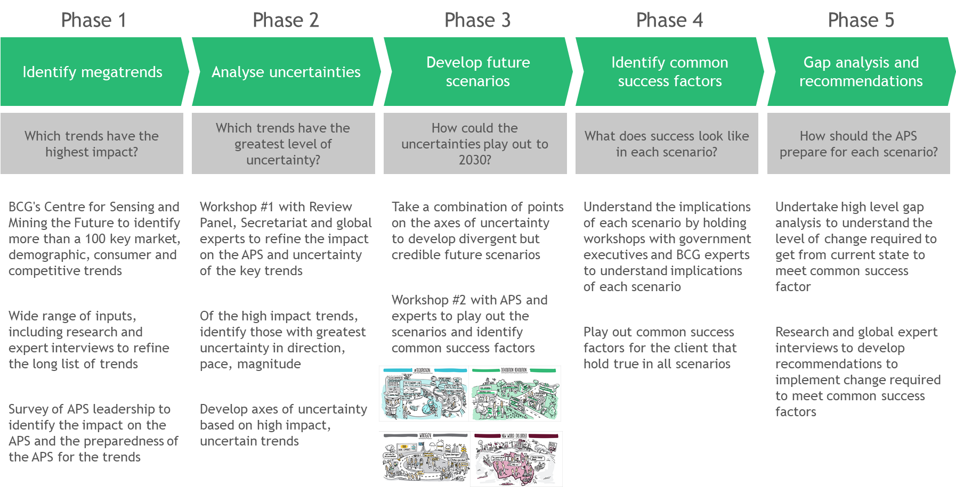

In Phase 1, we compiled a list of over 100 megatrends from a review of megatrends literature, analysis of proprietary data and interviews with experts (Figure 2). Each trend was tested to determine its potential impact on the size and scale, role, effectiveness, efficiency and productivity of the APS.
Figure 2: Long-list of megatrends that may be relevant to the APS operating environment
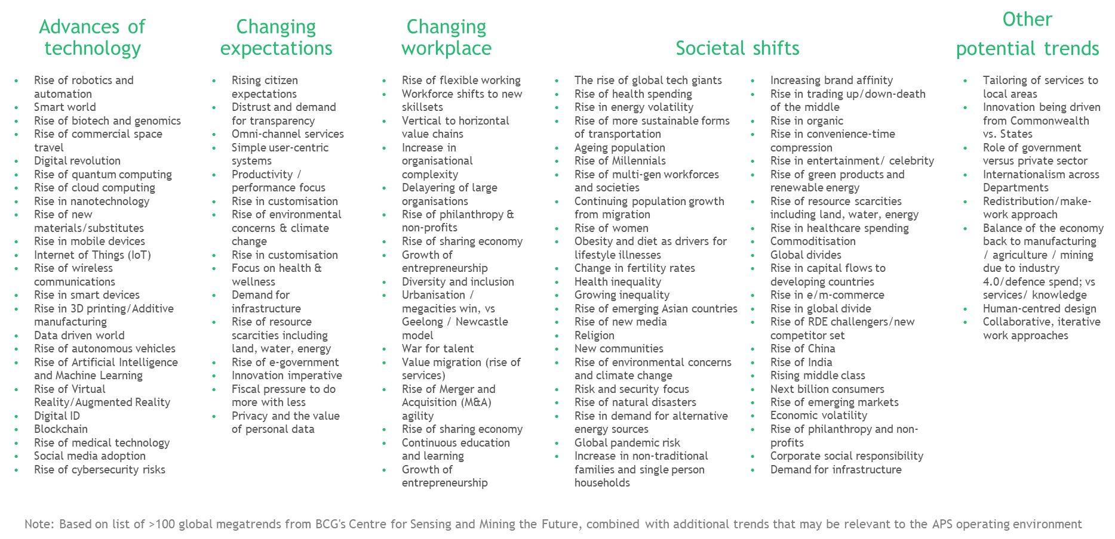

From this analysis, we identified a shortlist of 31 megatrends with the most relevance for the APS operating environment in 2030 (Figure 3). Shortlisted megatrends were grouped into four themes:
- Changing expectations
- Advances in technology
- Societal and geo-political shifts
- Changing nature of work

Figure 3: Shortlist of 31 megatrends identified as most relevant to the APS operating environment
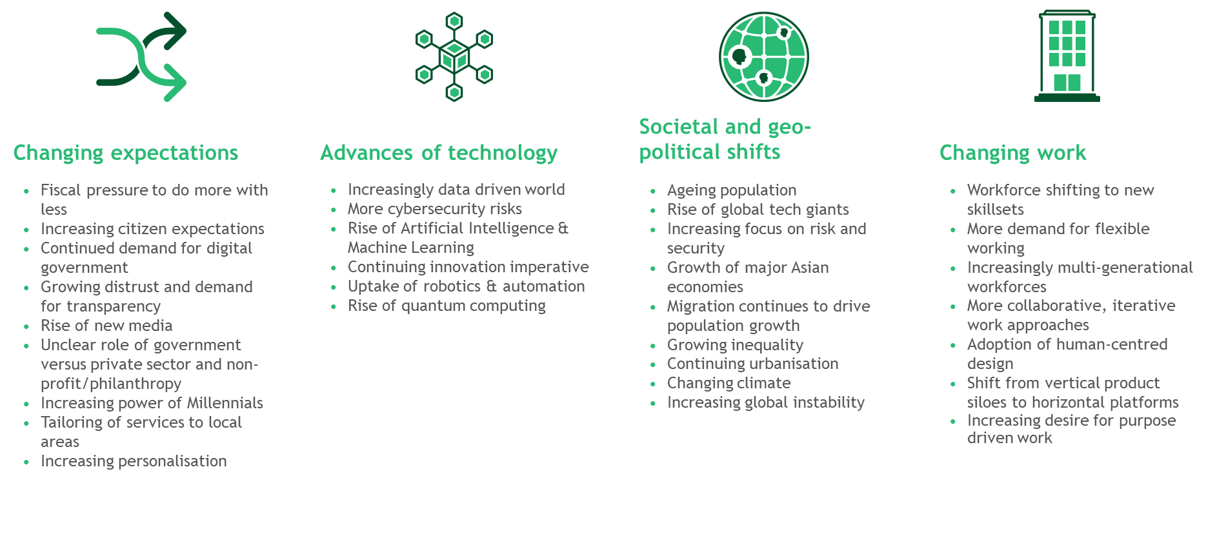
To assess the level of impact that the megatrends could have on the APS we surveyed APS leadership (EL2 and above), receiving responses from 2,756 leaders across 82 Departments and agencies. The results of the survey were presented in workshops with global and Australian experts, members of the APS Review Panel, the APS Review Secretariat, and BCG experts. In addition, we interviewed a range of global and Australian experts in megatrends, scenario planning and public service. From this work, we could identify and prioritise the highest-impact, most uncertain megatrends for the APS.

In Phase 2, this list of highest-impact, uncertain megatrends became the basis for three ‘axes of uncertainty’ that map the critical dimensions of the megatrends (Figure 4).

Figure 4: Axes of uncertainty
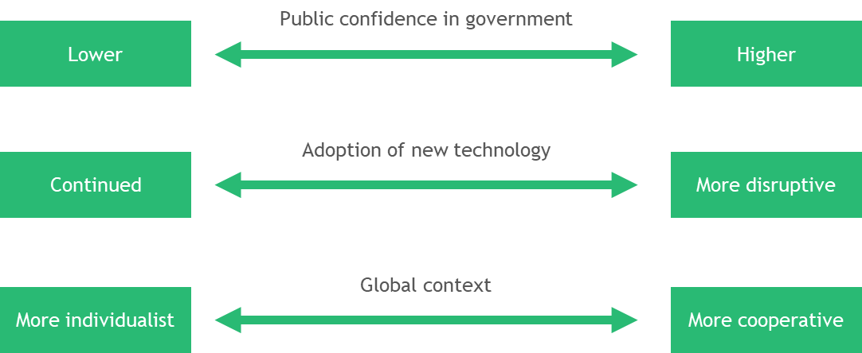

By focusing on the megatrends with the greatest levels of uncertainty, it is possible to identify scenarios that both cover the spectrum of possible futures and challenge orthodox thinking. A focus on megatrends with low levels of uncertainty alone, will not robustly test what is necessary for success, however these megatrends play out. Though megatrends with low levels of uncertainty are included in the scenarios, they do not differentiate between the different possible future environments.

In Phase 3, we developed four plausible but thought-provoking scenarios based on a spectrum of outcomes along these axes (Figure 5). The scenarios are built on the detailed research and analysis undertaken in Phase 1. Each scenario is developed by placing it on a chosen point along each of the axes and also reflects the potential outcomes of the other related megatrends, as shown in Figure 5. The robustness of these scenarios is tested using Black Swan and Thinking in new boxes methodologies to make sure they challenged conventional thinking and stretched the breadth and depth of the scenarios. The purpose of the axes is not to cover all possible futures, or to predict the actual future, but to make sure the scenarios represent a spectrum of possible futures.

Figure 5: Scenarios mapped to points on the axes of uncertainty
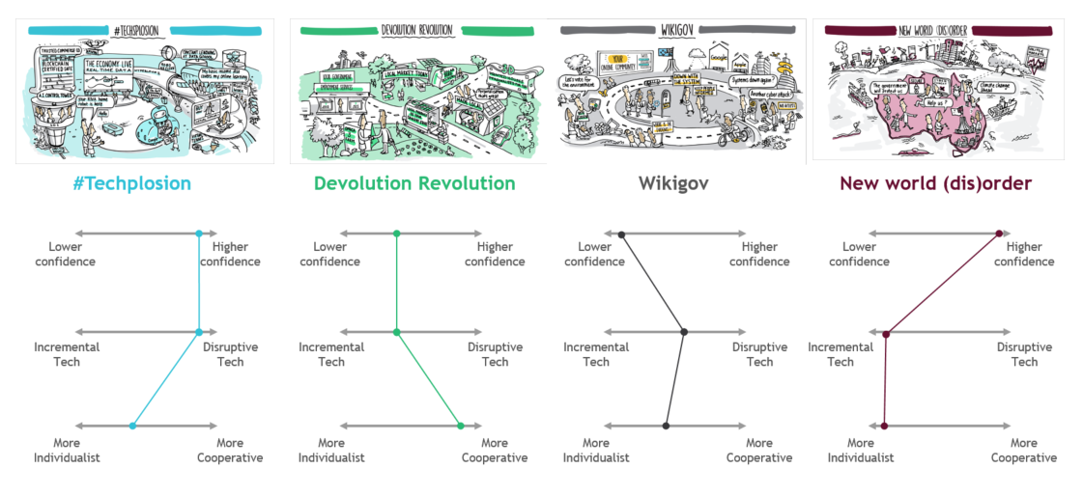

In Phase 4, we identified common success factors for the APS in all four future scenarios, based on a series of workshops and interviews with APS executives, the Secretariat and a range of experts. Following this, a gap analysis compared the current state of the APS to what will be required in the future.

In Phase 5, we combined insights from the common success factors and the gap analysis to develop eight recommendations for the APS to succeed in all possible futures.

Megatrends
The first phase in the scenario development process is to understand the megatrends that will affect the future operating environment. Of the shortlisted underlying megatrends that were identified as relevant to the APS, 20 were identified as high-impact.

These 20 high-impact trends were assessed to test their impact on the APS in 2030 and grouped into four overarching themes:
- Changing expectations
- Advances in technology
- Societal and geo-political shifts
- Changing nature of work

The four themes and their highest-impact trends are summarised below. More detailed descriptions of all the trends are included in the appendix.

Theme 1: Changing expectations
The Australian Public has vastly different expectations of the Australian Government and the APS than they did 20 years ago, and these expectations are likely to keep changing. Expectations cover the role of the APS, how it functions, how it engages with the Australian public, and the transparency and visibility of its operations. Many changes in expectation will be driven by broader changes in the economy, technological capacity and access to information, which have the potential to shift the role government plays in meeting public needs. The uncertainty of this theme is the extent to which these expectations change and in what direction.

Highest-impact trends
- Growing distrust and demand for transparency: Public trust in large institutions declines. This drives increasing scrutiny of all decision making. Pressure builds on the APS to provide more transparent processes and stronger accountability mechanisms.

- Tailoring services to local areas: People are more focused on their local area and place greater legitimacy in local solutions and local organisations. Authority, policy development, and service delivery for specific demographic and environmental requirements devolves to local government.

- Fiscal pressure to do more with less: Governments face increasing pressure to spend efficiently, justify public spending and demonstrate effectiveness, driven by the aging and growing population.

- Increasing citizen expectations: Australian public expect government service levels to keep up with increasing expectations shaped by experience of other organisations. Pressure builds on the APS to match, or exceed, the quality of service provided by leading institutions.

- Continued demand for digital government: More government interactions with the Australian public occur through digital channels. This drives increasing demand for the APS to develop and procure new digital platforms to deliver or facilitate core services.

Theme 2: Advances in technology
Rapidly evolving technology, powered by data, has pushed the world forward at an ever-increasing pace, which is expected to continue into the 2020s. Data generation and hyper-scale computing has exploded in the last ten years and shows no signs of slowing. Computational power, data visualisation and data analysis techniques are expected to keep advancing. Once automation passes a tipping point, it could fundamentally change all aspects of work and society. There is significant uncertainty in how this will play out. The development and adoption of specific technologies could continue, slow or accelerate. It is unclear how society will react to the advances of different technologies. Government, will face challenges in responding to social change and potential dislocation, tackling cyber-security threats, and managing a re-shaping economy. Opportunities will arise for government to harness the power of data and technology to understand public needs, solve complex problems and drive policy.

Highest-impact trends
- Rise of quantum computing: An increase in computing power means more information can be processed exponentially faster and using less energy, with the potential to change the type and volume of analysis undertaken by the APS.

- Rise of artificial intelligence and machine learning: Increasing developments and new applications of artificial intelligence and machine learning offer possibilities to improve processes within the APS and service delivery for the Australian public.

- Increasingly data driven world: The amount of data stored, processed and published increases exponentially. Citizens expect value in exchange for sharing data, as well as security about how their data will be used and protected. Managing information and extracting value from it will become a critical capability for the APS.

- Uptake of robotics and automation: The application of robotics and automation drives efficiency and improves the public’s experience. This displaces some jobs previously done by humans and creates demand for new skill sets.

- More cybersecurity risks: A large amount of data is stored on internet-connected systems. This increases the risk posed by unauthorised access to internal systems and many organisations lack the skill set to adequately protect themselves against this risk. At the same time, citizen expectations of the APS to minimise this risk also increase.

Theme 3: Societal and geo-political shifts
Society is very different today than it was 15 years ago and is likely be substantially different again in the future. What it means to be ‘Australian’, who we are, where we are from, what we are concerned about, and where economic and political power resides will change. This will be driven by a mix of local and global trends in economics, technology, politics, education and demographics. The nature and role of local, regional and global spheres will change. The way individuals and groups respond to the trends impacting Australia will reshape the future of Australian society. Government will need to adjust to respond appropriately to societal shifts. For example, government will need to manage its perceived or actual legitimacy, citizen expectations of government, the level of control and influence it has, and how it delivers societal outcomes. Many of the trends that will determine this change are a combination of global influences and actors and therefore, highly uncertain.

Highest-impact trends
- Increasing global instability: Changes in the global, political and economic environment shift nation state power dynamics and modes of communication, with potential waves of populist nationalist sentiment or a resurgence in globalism.

- Rise of the global tech giants: The prominence and impact of mega data mean the tech giants have strong relationships with Australians and are an integral part of their daily lives. The growth of their power raises questions of partnerships, regulation and ownership of service delivery for the APS.

- Growing inequality: Distribution of assets, skills and opportunities within Australia increases. Failure to address it reduces credibility of the APS. Inequality is not limited to financial measures. It includes disparities in health outcomes, education outcomes and technology literacy and engagement.

- Growth of major Asian economies: China, India and Indonesia account for more than half of the world’s economic growth to 2030. As the largest economies in the world, these nations become critical players in the physical and economic of Australia.

- Increasing focus on risk and security: Factors including global terror, information security risks, and awareness of environmental threats drive continued focus on risk and security at individual, state and national levels.

- Ageing population: As a result of life expectancy lengthening and fertility rates remaining low there is a steady increase in the proportion of Australia’s population aged over 60. This causes the APS to rethink social service and health systems, and cater for an older and more age diverse workforce.

Theme 4: Changing nature of work
Some degree of automation is highly likely to occur in the 2020’s. Less certain is how fast this happens, the extent of roles impacted, how the technologies evolve and how companies and the workforce responds. The impact on Australian society and the Australian economy is also likely to be significant, with changes to the jobs that exist, the skillsets needed, working patterns and employment terms.

Highest impact trends
- Workforce shifting to new skillsets: Changes in the economy and technology change the nature of work and skillsets required for specific jobs.

- More demand for flexible working: Employees increasingly expect employers to offer flexible work arrangements (e.g. time, location, tools and teaming). These are critical to attract and retain talent, particularly as jobs increasingly shift to higher skilled roles and a focus on emerging technologies.

- More collaborative, iterative work approaches: New, flexible and more nimble work approaches become prevalent, driven by changes in technology and work. New service delivery approaches focus on value, outcome and speed of delivery.

- Changing organisational structures: Traditional vertical organisational hierarchies move towards flatter, horizontal platforms as agile working approaches become the norm and the increasing use of technology reduces frontline roles.

Scenarios
We used these trends to develop four scenarios that depict the operating environment for the APS in 2030: #techsplosion, WikiGov, Devolution Revolution and the New World (dis)order. These scenarios were designed to explore the range of possible future environments based on the potential trajectories of these trends. Across the four scenarios, different trends have been selected, and there is variation in how strongly those trends have played out. The trends were analysed, in workshops and expert discussions, to identify what the APS would need to look like in each scenario, and how it would need to function to be successful. The following descriptions set out each scenario and how the APS would need to function differently compared to today to be successful.

It is important to keep in mind that the scenarios are not a predication of the future. Rather, they demonstrate a broad spectrum of possible futures. In the real future, the APS operating environment will most likely include elements of all four scenarios.

SCENARIO: #TECHSPLOSION
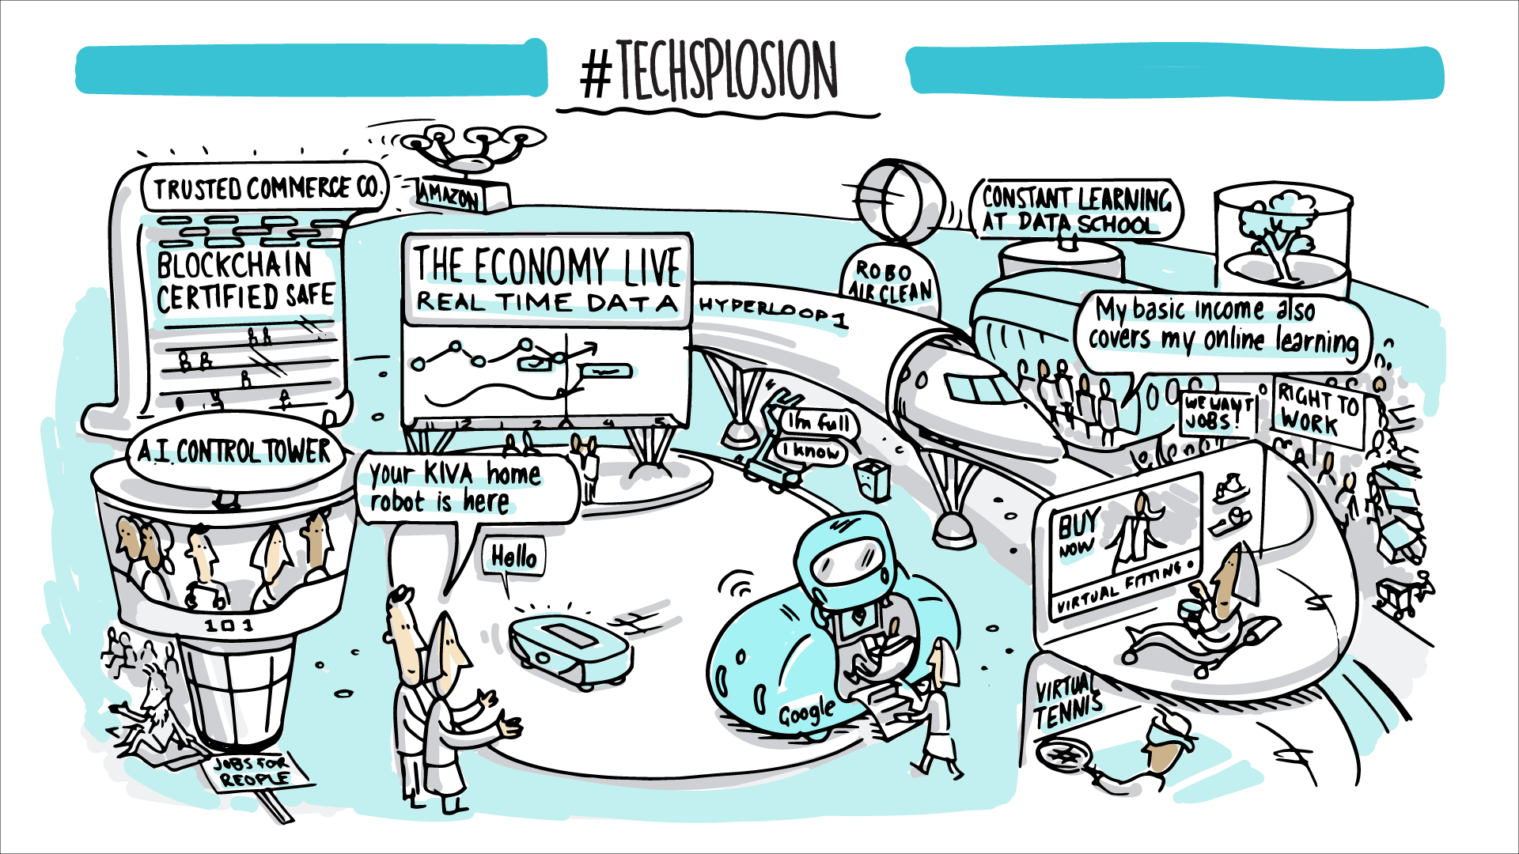

Imagine a world where…
Disruptive technologies have developed at an accelerated and exponential pace, and Australians are early adopters who continue to embrace new technologies and the possibilities they offer to improve their lives. Huge leaps in the evolution of quantum computing have turbo-charged the power of machine learning and AI at scale, supporting mass personalisation and optimisation. Breakthroughs in blockchain technology have changed the game for traditional technology platforms and systems. Bio-technology implants replace physical devices as the primary way to access digital services and communication. Real-time monitoring and genomic mapping drive more effective, tailored health and wellbeing interventions.

The rapid rise in workforce transitions has been harder to manage, leading to higher levels of redundancy and unemployment, and growing inequality in favour of people with specialised skills (e.g. developers and data scientists). People also expect and trust the public service to keep up with technological change, and employ the latest, best innovative technology. Data sets are connected and more readily accessible, enabling government to adjust policies and services quickly if they aren’t delivering the outcomes that people expect or need.

Key trends that have got us here…
- Increasing personalisation – This scenario reflects rapidly increasing demand for personalisation. Australians share more personal information and expect products and services to be tailored to their individual needs. Education is completely personalised based on preferences, employment data and other sources. Pharmaceutical companies use customer genome information to offer personalised healthcare products. The private sector has maintained good standards of data security. People look for tailored services and products that improve their lifestyles.
- Rise of Artificial Intelligence and Machine Learning – The development and use of AI and machine learning has undergone a significant step change. Their uptake has risen exponentially and the global AI market has grown to over $90B. This has affected Australia significantly and AI is used at scale in most industries.
- Increasing data-driven world – Data creation has accelerated exponentially, and at a much greater pace than expected. People willingly sharing a wealth of personal data with little hesitation. Advances in data analysis give the public and private sectors new possibilities to use and process this data.
- Rise of quantum computing – The global quantum computing market has accelerated dramatically and improved computational capacity. This faster than anticipated progress means computers are processing data 500 times faster than in 2018, drastically increasing the volume and speed of analysis of shared data.
- Uptake of robotics and automation – The scale of automation has grown significantly due to advances in technology. Over 60% of Australian jobs are automated, 40% more than predicted in 2018. Manufacturing jobs are performed entirely by robots. Healthcare is increasingly robotics-dependent, and many surgeries are performed by surgical robots or aided by artificial intelligence.
- Growing inequality – Inequality has risen at a steady rate, driven in part by the changing workforce. The wealthiest 10% of Australians hold a greater concentration of wealth than ever before. A handful of professional skills, including technology skills, are paid more than ever before. People working in the service and primary industries are struggling to find work and their real wages have declined by 10% in the past five years.
- Workforce shifting to new skillsets –The skills required in the workforce have fundamentally changed. Many tasks in entry level jobs and jobs with high proportion of cognitive repetitive tasks are automated. Technology and data skills are at a premium, and companies need employees with these skillsets to take advantage of the potential of big data and AI.

REQUIREMENTS FOR THE APS…What does success look like?

Leading in technology and data capability

The APS has kept pace with advancing technology and has developed broad ranging technology capability and skills, in AI, machine learning, analytics, quantum and cybersecurity. It has achieved this by working closely with industry (particularly big technology companies and start-ups), academia and NGOs, and designing secondment programs which facilitate the movement of key talent into the APS. The APS offers competitive salaries for data scientists, designers, analysts and other in demand skills, and has communicated the values and benefits of the purpose driven work available in the public service. Top graduates and global technology talent view the APS as an employer of choice.

Using technology and big data to personalise policy and services

The APS is leveraging AI and machine learning to analyse big data sources. It is using these insights to inform policy decisions and redesign services to best meet the individual needs of the public. Data on outcomes is fed back in real time and policy and service delivery is regularly improved and adapted. Government services can be accessed through a variety of channels (both digital and physical) and are increasingly delivered by AI with a choice of automated or manual service interaction. All agencies offer services through a chain of virtual offices where people can interact with centrally located staff through virtual reality technology and conduct their interactions in one place. Services are increasingly designed around individual needs with life event and analytics based triggers which push interventions, services and support to people based on where they are in life. These life events are identified through analytics insights such as changes in shopping habits.

Working in multi-disciplinary and cross-functional ways

All APS organisations have adopted multi-disciplinary working with staff aligned to capabilities and deployed to teams and projects where their skills are most required. These teams are aligned to agendas and outcomes and draw people from various agencies. This is core to APS working and extends beyond projects to all permanent teams. Agile ways of working have been adopted at scale – with small teams assembled from the most suitable staff across the APS to achieve specific outcomes. These teams are able to easily collaborate and draw upon specialised knowledge as desired, both within the APS and from the private sector.

Maintaining an interconnected network of shared resources and information across the APS
Technology infrastructure, knowledge and data is shared across the APS. Specialised infrastructure exists in specific agencies and is used by other agencies and agile teams as required. This ensures more efficient use of resources and promotes the development of expertise in the public service. Digital platforms enable APS-wide knowledge sharing and act as a database for learning and development. Common interfaces and standardised systems allow effective working with state and local governments, NGOs and the private sector.

Maintaining strong cyber and data security across the APS

The APS has invested heavily in technology architecture and cybersecurity, and is now recognised as a leader in the field. Data sharing is common, structured and secure with minimal data leakage. Standard data management protocols are in place across the APS and data storage has been significantly improved to provide effective shared databases for analysis.

SCENARIO: DEVOLUTION REVOLUTION
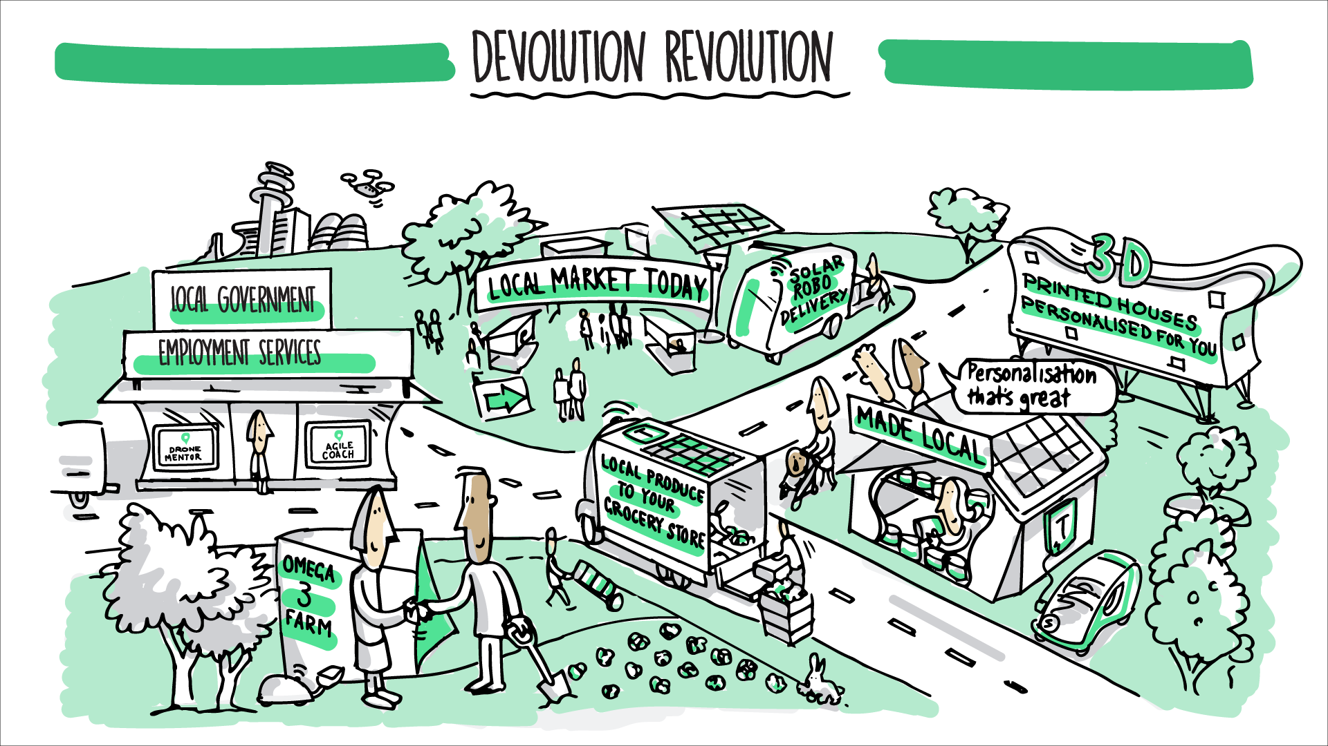

Imagine a world where…
People are losing trust in big institutions. They are re-connecting with their local communities, buying local and relying on community services. The banks, big companies and old established brands are seen as self-interested and ignorant of what really matters at individual and community levels. Start-ups and local enterprises have filled the gaps left by large institutions to become a larger part of the economy, displacing the banks and retailers in a number of communities.

Most Australians have become dissatisfied with standardised public services. To respond to demands for more complex and tailored services, government has devolved more policy and service design to state and local governments to promote placed-based approaches. Local delivery of health, education and social services, in partnership with industry and community organisations, is often the only direct interaction that government has with most Australians. As a result, the shape of the federation is changing. A range of traditional APS functions have been devolved to state and local governments, while the national government is focused on national-level policy, such as foreign affairs and national security.

Key trends that have got us here……..

- Tailoring of services to local area – This scenario explores the significant increase in the demand for tailored services tailored to local needs. Early place based initiatives were hugely successful. As a result an increasing number of place based approaches have been adopted across Australia, with policy and service delivery tailored to specific demographic and local requirements.
- Increasing personalisation – Demand for personalisation moderate. Australians are still willing to provide data for tailored services but, personalisation is driven much more by location rather than individual need.
- Fiscal pressure to do more with less – Fiscal pressures in this scenario have worsened significantly since 2018. Governments haven’t been able to take any significant actions to bring budgets back into surplus due to challenging economic circumstances. Australian government debt has now risen to $1.2T. Spending on aged care and health spending has increased to 3.3% and 5% of GDP respectively. There is significant pressure on the APS to deliver more services for less, in order to accommodate the growing needs of Australia’s ageing population.
- More collaborative, iterative work approaches – The adoption of more collaborative work approaches has rapidly grown. An increasing number of private companies and large NGOs have adopted agile at scale operating models. High quality talent are demanding new ways of working. Collaborative technologies have made virtual working even easier and now a significant proportion of the workforce regularly works virtually at least one day a week.

REQUIREMENTS FOR THE APS……What does success look like?

Using more place-based approaches to tailor policy and service delivery to local needs

The APS has greatly increased the distribution of its people and services with strong presence in all regions, dedicated leadership in the regions and delegated authority for regional APS centres to develop local policy and tailor delivery to local needs. A range of traditional APS functions have been devolved to state and local governments, NGOs and communities to give autonomy to those who best understand local needs. The APS now works closely in all areas with NGOs, think tanks, academia, industry and communities to share knowledge and capability which can improve local outcomes. Services are delivered by a varying constellation of providers in each area, and services offered are tailored to local needs. Budgets are increasingly focused on outcomes and assigned to areas rather than to agencies at the national level.

Setting national standards for policy and service delivery

In order to ensure the quality of policy and service delivery at a local level, the APS has positioned itself as a standard setter. It provides oversight of state and local governments and other place based providers, within clear frameworks to ensure equality of outcomes for the Australian public. It sets overall policy direction and targets with local areas setting specific local targets and approaches. The APS also has centres of excellence which provide best practice knowledge on policy and service delivery. Local providers can draw on this expertise as required. In addition, it has designed a number of transparency mechanisms to publish data on targets, spending and achievements, and implemented a range of forums for local communities to ‘vote’ on the policies and services in their area.

Maintaining a strong central APS focus on national issues

While the APS has devolved control for some aspects of policy and service delivery, it has increasing control over many issues which cut across state and local boundaries. It has strengthened capability in defence and cybersecurity and is more active in managing national investments (e.g. interstate infrastructure, energy generation etc.) There has been strong reform on energy and environmental policy and clear frameworks for achieving national targets (e.g. our commitments to climate change). Funding tied to these targets provides a powerful lever for the APS to drive outcomes.

Adopting more agile ways of working with smaller teams

The structure of the APS has been delayered, with focus on agile teams with significant devolved decision-making authority. These teams are routinely made up of APS staff from different agencies and functions, and are supported by collaborative technologies to allow for geographic spread and rapid forming and reforming of teams. The APS routinely includes non-APS partners in its teams and APS staff are deployed to teams and functions operated by state and local governments, NGOs and the private sector.

Connecting key organisations and providing specialised capability

The APS helps bring much needed capability and collaboration to a more devolved system by linking key organisations and services. It provides seamless platforms that safely store, process and share data. Central APS teams provide much needed specialist capability, in areas such as big data analytics, to decentralised bodies.

SCENARIO: WIKIGOV
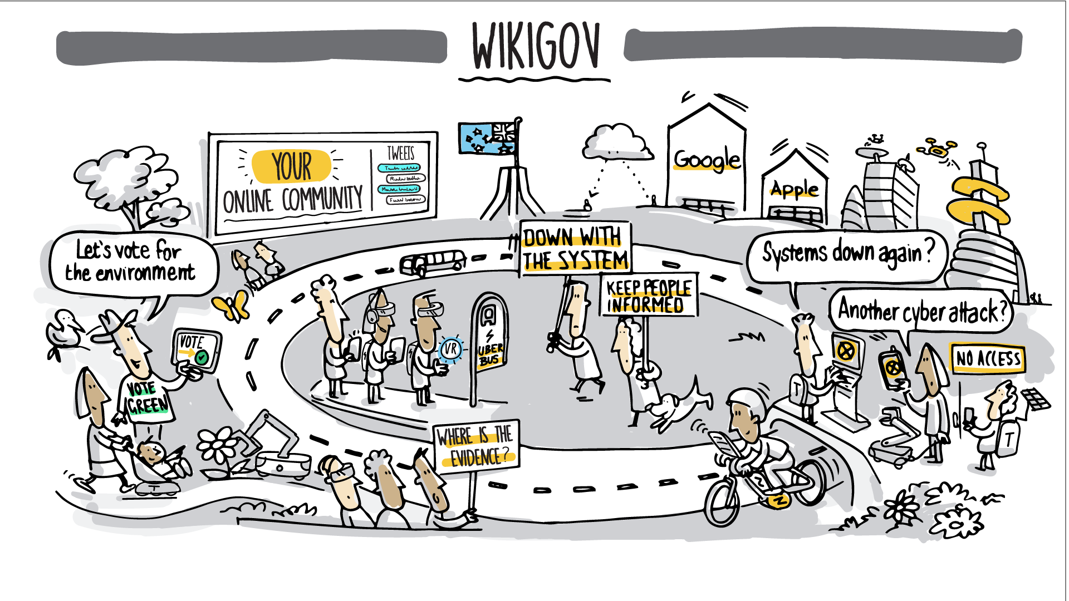

Imagine a world where…
The Australian public’s trust in institutions has rapidly declined. Trust in the APS has also fallen, and it is struggling to make progress on issues. Governments of all levels, plus private sector organisations and NGOs, are subject to increasing scrutiny. Citizens are engaging less and may think the system needs to change.

Progress halts on many issues of national importance, such as economic reform, energy, water, climate policy, immigration and trade. People are frustrated with traditional institutions and opinion polls continue to show historically low levels of trust.

Rapid advances in social media and personal device technology have continued. Highly personalised social media ‘echo-chambers’ have all but supplanted the mediums that Australians traditionally use to source their news and current affairs. Traditional journalism has been disintermediated and polarised corporate and partisan coverage is the norm.

The Australian public are increasingly taking governance into their own hands. People are using new online technology platforms to engage with the public service directly, shaping policy on the issues that matter the most to them.

Key trends that have got us here……..

- Growing distrust and demand for transparency – This scenario explores the most extreme relative distrust in government institutions. The Australian public’s trust in institutions has rapidly declined. Governments, private sector and NGOs are all subject to increasing scrutiny. The large majority of Australians think our system of government needs reform. Trust in the APS has fallen in line with this change and Federal Government is ranked as the least trusted of all institutions.
- Rise of new media – This rise of new media has continued unabated. The majority of Australians now access their news through social media. Almost half of Australian newspapers have ceased to publish and the majority of those that remain only publish digitally. More than 90% of under 25s state that they have never read a newspaper and don’t trust journalists. Facebook has continued its dominance, and a number of other new social media platforms have gained popularity. Global digital advertising spend has continued to increase, and echo chambers continue to feed confirmation bias. News is increasingly driven by sensationalism and click through.
- Rise of Artificial Intelligence and Machine Learning – The adoption and development of AI and machine learning has increased steadily. Scaled use of AI is occurring in most industries and the projected 40% displacement of jobs through automation has occurred.
- Increasing data driven world – Data growth has increased. The use of data is still driven largely by the global technology giants. People are wary of privacy and sharing too much data. They are willing to accept more generalised services from companies in order not to share too much personal information.
- Continued demand for digital government – People’s interactions with government are increasingly digital, growing steadily from 2018. The Australian public demands more functionality and greater access to government through these platforms.
- Rise of global tech giants – Global technology giants have continued to gain popularity. The rate of acceleration of this trend is extreme. The market capitalisation of the 7 largest technology firms is now nearly 7 times Australia’s GDP. These firms increasingly have more access to data, and are providing more services directly to the Australian public.

REQUIREMENTS FOR THE APS……What does success look like?

More open and transparent APS
The APS needs to develop mechanisms which give the Australian public much greater insight into political processes. Cloud-based open ledger solutions support accountability and transparency, revealing the financial implications of government spending in real time. There is mandatory reporting and disclosure of all non-confidential data used by government. The APS needs to maintain strong specialist new media capabilities which interact directly and broadly with the public, disseminating information, policy and plans and providing direct ‘retail’ channels for individuals to interact with the APS.

World class digital capability

There is extensive specialist digital capability within the APS. The APS has developed a number of government platforms, which have been rolled out at scale. These are used by local and state governments as well as APS bodies to deliver services. The APS has attracted world class UX designers, computer scientists and human centred designers. This has been achieved through competitive salaries and close collaboration with incubators.

Greater citizen engagement

The APS is driving public engagement and participation through multiple avenues. An open and transparent budget process enables greater transparency ensures all stakeholders are appropriately represented. Open voting platforms allow citizens to engage directly on issues which matter to them. The APS has a more decentralised footprint to drive local engagement and tailor policy and services to local needs. Engagement is driven through a variety of different channels – with the APS providing both digital and physical fronts to ensure convenience for the Australian public. The APS also promotes public discourse on policy issues in a range of forums outside of social media echo chambers. Public forums, virtual juries and real-time voting initiatives allow people to regularly interact directly with Government policy and services and shape how government behaves.

A more efficient APS

In order to create efficiencies, the APS shares distributed resources and capability across agencies. In particular, the APS uses a technology stack approach, and selects the most appropriate data and technology capability and infrastructure for each specific project. The APS has restructured substantially with a significant proportion of staff working in persistent multi-disciplinary agile teams. Federal agencies focus on their role as providing the overarching infrastructure for communities of organisations to deliver outcomes within their agenda. For example, the Department of Health provides genomic mapping capabilities and analytics tools for healthcare providers to tailor services to individual genomes.

Services which cater to the citizen journey

The APS has restructured its public facing services to be structured around an individual’s journey. By partnering with state and local governments, the APS now provides a common and interoperable platform for all government services (national, state and local) with offerings aligned to life event journeys. People are receive services over time in line with that journey, modified for the circumstances they declare. This significantly improves convenience for people. Open digital platforms make government services easily accessible wherever it suits the citizen, and actively assist individuals to fast track many interactions. These approaches are designed to minimise specific data requests from people and to use standard data sets to tailor offerings with individuals able to opt in or out.

SCENARIO: NEW WORLD (DIS)ORDER
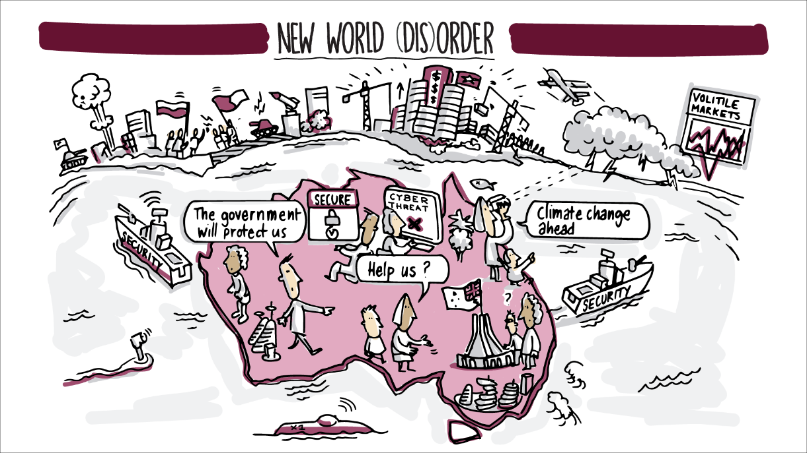

Imagine a world where…
Global instability on all levels – political, economic, environmental and social – has made nations turn inwards.

Global power has shifted to China and other major Asian economies (e.g. India and Indonesia). The US, driven by strong nationalism, has largely disengaged from the Asia-Pacific region. Global organisations such as the UN and WTO have little to no impact. Nations are moving towards using bi-lateral agreements in lieu of trading blocs.

Around the world, countries and regions are in a perpetual state of near-conflict and populist nationalist views are the dominant political force globally. Tariffs on trade have risen markedly. The EU has a reduced number of member states, after more countries followed Britain’s exit, some voluntarily, some involuntarily.

Terrorism and cybersecurity attacks have continued to increase. Caution and conservatism around data security, privacy and cybersecurity risks have slowed the rate of technology adoption. The fuss about AI and automation in the workforce and elsewhere – such as autonomous cars – has turned out to be more hype than real, and is taking much longer to materialise due to technical, legal and regulatory impediments.

Global people mobility has fallen after successive governments have implemented skills-focused migration programs as global growth slows and economic conditions tighten. While increasing complexity and uncertainty present a challenging environment, increasing nationalism has helped to stabilise trust in government.

Key trends that have got us here……..

- Increasing focus on risk and security – This scenario explores the more extreme focus on risk due to global terrorism and other threats. Cybersecurity is now more of a concern than ever. Corporate spending on risk and security has now reached $800B. There have been an increasing number of terror attacks, high profile hacking incidents and data breaches.
- Growth of major Asian economies – Emerging markets in Asia have continued to grow, and now account for half of global spending at ~$30T. China and India are now the world’s largest economies, and Indonesia has continued to grow rapidly. European economies have shrunk relative to Asia and stagnated in real terms. Growth in the US has not kept pace with inflation.
- Increasing global instability – Global instability has significantly accelerated in line with the focus on risk and security. Far right political movements, emphasising nationalism, have continued to gain power. These sentiments have been felt in Australia, resulting in a drive to break down international agreements. Trade relationships which Australia once relied upon are in flux, and navigating the global political environment has become increasingly complex.
- Rise of Artificial Intelligence and Machine Learning – Since 2020, the pace of development and adoption of AI and machine learning has slowed significantly and large scale automation of jobs has not occurred. Early incidents of remote takeovers of AI machines and concerns around cybersecurity and risk have prevented mass adoption.
- Changing climate – As predicted, Australia’s CO₂ emissions have accelerated and surpassed 570Mt. Temperatures have continued to rise and its effects are evident – with Australia experiencing severe drought over the past 5 years.

REQUIREMENTS FOR THE APS……What does success look like?

Leader in cyber and physical security

The APS has positioned the Government as the steward and protector of the population. The APS has become a world leader in cybersecurity and the work of national security agencies has prevented terrorist attacks on the Australian mainland through extensive intelligence and use of data analytics.

Stewarding the Australian economy

The APS acts as a steward and key driver of the Australian economy. It has invested heavily in programs to develop skills in technology and key industries and has partnered with start-up firms to drive innovation. It has also helped create a robust and resilient economy that increasingly focuses on high knowledge industries such as bio-medical and pharmaceuticals through dedicated partnerships with key industries and the development and fostering of public-private partnerships in key initiatives. It has provided support and advice to the Australian Parliament on how to best use the government’s constrained resources for the benefit of the Australian public.

Strong key international relationships

The APS has successfully strengthened Australia’s relationships with China, India and Indonesia and other ASEAN economies by negotiating a number of new bilateral trade agreements and shifting to a more Asia focused foreign policy. This has been facilitated by having strong Asia focused capabilities and skills, including negotiation, contract management and bilingual expertise.

Foster internal innovation

Given the significant constraints on resources and the increasing proportion of resources spent on security, the APS has had to pioneer innovative approaches to meeting citizens’ needs. Performance management has become much more closely tied to impact, and a range of working practice policies have been relaxed to enable staff to take initiative and to reward them for risk taking and innovation. A try, fail and learn culture has been pioneered to give individual APS staff increasing autonomy to develop and try out new ways of delivering services and achieving outcomes. Using data and analytics to identify insights and to model potential outcomes has become the norm with all teams and functions having analytics specialists. Software and data infrastructure has expanded significantly to enable better, quicker analysis by analytics specialists deployed in frontline teams rather than dedicated analytics teams.

A more fluid structure

The APS has adapted its operations to increasingly provide more government services to the Australian public for less through significant changes to organisational structures and restrictive employment practices. Virtual working has increased significantly and staff are increasingly located across Australia. Agile approaches have become the norm with agencies restructuring to become agile organisations in line with many of the approaches pioneered by large technology firms, allowing staff to move more freely and regularly between agencies and functions. Team and individual performances are structured around clear measurable outcomes to incentivise productivity and further reinforce innovation. Teams are driven to deliver on outcomes and there is clear data and evidence to monitor and report on achievement. Within portfolios there are now multiple groups and communities which undertake policy development and delivery without fixed staffing.

Common success factors
While the APS would need to operate differently to succeed in each scenario, we identified a number of success factors that were common across all four scenarios. Building capability in each of the common success factors will allow the APS to take advantage of the upside opportunities and prepare for the downside risks of all scenarios. We have undertaken a high-level gap analysis of each success factor to assess the gap between the APS today and 2030, and to focus the recommendations on how to close the gap (Figure 6).

Figure 6: Common success factors, gap analysis and recommendations
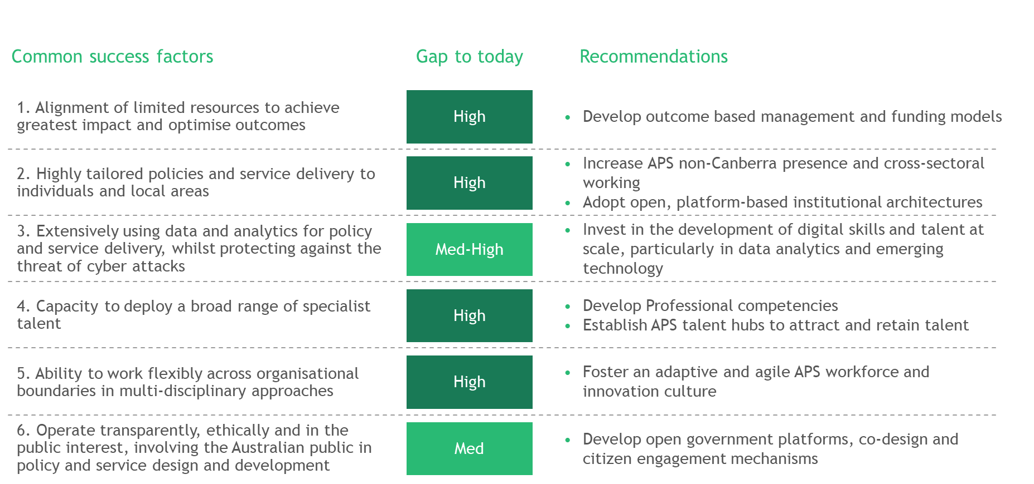

Our recommendations focus on early potential actions, rather than a comprehensive program to deliver the common success factors. A more detailed capability assessment and program of work would be required to fully close the gaps. The following section outlines each common success factor, the results of the gap analysis, and recommendations to take to set up the APS to achieve success in each factor.

1: Alignment of limited resources to achieve greatest impact and optimise outcomes
In all scenarios, the APS will need to keep doing more with less. The ageing population, growing inequality and increasing demand for services will stretch government resources, even if the economy is strong and growing. In all scenarios, the Australian public’s higher expectations were based on increasing personalisation of services, greater and more complex needs, or a move towards place-based service provision.

Actions to meet these rising expectations and place-based service provision will not succeed unless funding and targets are focused on outcomes for the local population. In addition, personalisation will have less impact if the primary focus is on delivering an intervention instead of achieving an outcome. The impact of new technologies on the workforce, government operations and the international economy will also need to be factored in and responded to.

During the scenario planning process, workshop participants identified that the APS will need to develop and deploy a new funding model to set outcome targets and allocate funding to those targets, across organisational boundaries. For example, funding for the care of a person with dementia is linked to the health outcomes for that individual, not to the provision of health interventions, social care or occupational therapy. The activity to deliver those outcomes would be dictated by what is best for the individual, not the organisational responsibility.

Success for the APS in all scenarios requires the capability and processes to manage budgets and targets across traditional boundaries, with structured oversight, transparent spend and shared metrics.

Gap analysis
Current spending in the APS is mostly aligned to agencies and activities, rather than to outcomes. Even when agencies are working on the same policy agenda, their budgets can be linked to different outcomes, often with competing financial agendas, which leads to perverse incentives. For instance, a hospital and a community social services provider both have responsibility for the health outcomes of an unwell elderly person. However, the hospital is incentivised financially, and often required to discharge as quickly as possible even if it leads to poorer outcomes and higher whole-of-life support costs. Accounting and budgeting rules restrict the way money can be managed, and put pressure on agencies to exhaust their allocated spend within artificial timeframes (financial years, forward estimates etc.) For example, in the last month of the financial year, the proportion of short-term contracts commissioned increases from 18% to 33% as agencies utilise their budgets. Spend is not transparent and procurement focuses on competitive processes over shared delivery of outcomes with partners.

Outcome monitoring is stronger, but still aligned primarily to agencies rather than shared outcomes. Monitoring is largely driven by activity-based Portfolio Budget Statement (PBS) measures and metrics that are not SMART (specific, measurable, achievable, relevant, and time-bound). Significant inconsistency remains between how agencies and levels of government set and measure targets, with little alignment between agencies with overlapping interests.

Survey: APS senior leadership indicated that, of all trends, fiscal pressure to do more for less will have the highest impact on the APS

Recommendations

Develop outcome based management and funding models
The APS will need to develop and implement a strong outcomes-based management budgeting process. New Zealand’s Better Public Service Results program set ten challenging cross-agency priority targets, each with its own measurable goal and timeframe. Funding then was prioritised for initiatives that would meet these targets. The program delivered strong results, with greater coordinated activity and more streamlined spend. In education, for example, the number of Maori students achieving higher secondary qualifications (NCEA Level 2) increased by 20% in five years.

Genuine outcome-based management and budgeting would be a significant shift for the APS. Central agencies will need to take a lead role and work with all agencies to develop the outcomes (based on government policy and priority), set metrics, identify activities to deliver the outcomes, and allocate funds accordingly.

Portfolios and agencies will bid for funds based on their ability to deliver outcomes. In addition, non-APS bodies (e.g. state and local governments, NGOs) might collaborate and be able to propose to undertake activities and be allocated funding for them. This will create a genuine market for the delivery of outcomes in key areas. It will also foster innovation and help to align funding to the activities that deliver the best outcomes.

Specific actions for the APS include:
- Modify accounting and budgeting practices: Accounting and budgeting processes need to be re-aligned with outcome-based management. Within these new processes, budgets and incentives will also need to be aligned. For example, funding for some outcomes may need to be untied from time periods so that it does not expire at the end of a financial year.
- Set SMART metrics for Government outcomes: A small number of outcome-based goals provide a direct line of sight between actions and results, and track progress easily.
- Implement cost transparency: Baseline cost transparency reviews analyse all public sector and associated spend linked to an outcome area (e.g. mental health). Undertaking these reviews will define the outcomes being achieved, and highlight inefficient allocation of resources. An ongoing function will need to be established to undertake the cost transparency reviews, and to monitor spend related to an outcome across all associated organisations.

2: Highly tailored policies and service delivery to individuals and local areas
In all scenarios, the Australian public will demand higher-quality, highly tailored policy and services. These demands are driven by increasing personalisation in other areas of their lives, developments in technology and societal shifts. In all scenarios, services need to be delivered faster, at lower cost, and in the channel, time and way that people want. They expect a seamless whole-of-life experience and connected services that adapt as their circumstances change, and where life events automatically trigger the right services and support (e.g. births, illness, retirement).

During the scenario development process, workshop participants identified that the APS will need the capability to use personalisation and tailored service provision to meet individual and local area needs. Success includes more flexible policy design to accommodate variations in service provision, improvements in how data and information are managed to provide a lifecycle view of each person, and a menu of services that can be varied for them. To do this, the APS will need to work more closely with local area partnerships. More APS capability will be needed in regions, with more policy and service provision managed jointly with state and local authorities, and community groups. Additionally, the ability to deliver effective, tailored and low-cost services will be built upon the use of common Government as a Platform infrastructure.

Gap analysis
To work more closely with local area partnerships, the APS has trialled some place-based initiatives (PBIs) to provide tailored services to communities. The most recent review of place-based approaches looked at nine Commonwealth PBIs, a tiny fraction of the services offered by government, which indicates that most government services are still managed centrally. Of the nine PBIs reviewed, only 44% achieved flexible delivery and 77% demonstrated autonomy –possibly indicating some hesitance to fully let go of central governance.

In terms of location, around 60% of APS staff are outside the ACT but 73% of SES and 60% of EL positions are within the ACT. As a result, the APS is not set up to collaborate effectively on place-based solutions with local and community initiatives and other levels of government. According to the Australia and New Zealand School of Government’s Dean and CEO, Ken Smith, policies issued from Canberra often, “don’t integrate locally to meet the needs of a particular community, or recognise that the needs of a community on an island in the Torres Strait are very different from the needs of a community in western New South Wales or in north-west Western Australia.” While policy is currently in place directing redistribution to regions, little progress has been made to date. This is because the policy focuses on blunt movements of ‘agencies’ and does not make meaningful change to structures or the way organisations are operating.

The APS needs to do more to develop the capabilities required to effectively personalise and tailor services to regions, local areas and communities. Behavioural economics and randomised control trials are being used more often to identify and pilot tailored interventions, support and policy, and more investment is being directed to scalable solutions for individual service. However, standard policies and restrictive practices still limit the ability of agencies to vary service provision based on individual need. Cost pressures, highly manual processes and, limited investment in infrastructure for low-cost tailoring (e.g. digital personalisation capabilities) mean that agencies can generally only afford to deliver standard service offers.

Survey: “Citizen demand for changing their interaction with government is outstripping our ability to respond.” – EL2

Recommendations

Increase APS non-Canberra presence and cross-sectoral working
To tailor service delivery to individuals and local areas, the APS will need to significantly increase its local presence and its ability to work across sectors within local areas. To succeed, the APS will need to redesign how its organisations work to make them more aligned with regions. This includes decision-making and budgets (or a proportion of budgets) aligned to regional outcomes and controlled by regions. Regions will need a frontline service delivery presence, devolved decision-making for regional delivery (within national frameworks), and local SES and EL level leadership. Other bodies will need a regional presence with the ability to develop and tailor policy over time, and collaborate with local area initiatives, local and state governments, NGOs and the private sector.

Agencies will need more flexible, varied working practices to suit regional areas, and virtual working capabilities will require significant investment to retain joined up organisations and link sectors. Staff will need to work in multi-disciplinary teams across regional bodies, with APS staff deployed in teams led by other sectors and staff from other sectors deployed within APS-led teams. Recruitment practices will also need to be redesigned.

Specific actions for the APS include:
- More senior staff outside of Canberra: Leadership roles should only be in Canberra if they deliver direct advice to Ministers’ offices and central government, lead the limited number of corporate functions, or there are specific reasons for them to be in Canberra. All other leadership positions need to be close to staff and close to regions to lead collaboration and improve capability in the regions.
- Increase the use of common collaborative technologies and platforms: Shared systems, including telecommunications, cloud computing, cyber-security, common data protocols and open API standards, will support and improve cross-agency collaboration and regional distribution.
- Implement an APS-wide strategic partnership framework: A standard partnership framework will provide the base and direction to form regional and outcome-linked partnerships. For example, the European Commission's Smart Specialisation platform is an innovation platform that brings together stakeholders from different sectors to partner on the assets and resources available to their regions.

Adopt open, platform-based institutional architectures
The success of effective, tailored and low-cost services will depend on the use of common infrastructure. Digital disruption has entered a hyper-scale phase in which key capabilities are beyond the capacity of individual organisations. For example, medicine will soon be using genomic mapping to tailor treatments, but the technical capabilities, data and infrastructure required is beyond individual doctors or hospitals.

A few providers will develop the hyper-scale infrastructure required for a range of organisations to consume. Amazon is an example of hyper-scale capabilities in retail, providing individual retailers with marketing, pricing, sales and fulfilment platforms that no individual retailer can develop or maintain. This is the approach that governments need to take.

Platform capabilities will exponentially improve the ability of governments to tailor services, and reduce delivery cost. The APS is uniquely positioned to establish these capabilities for government as it can dedicate the resources needed to develop and maintain platform capabilities at scale.

The ideal future approach is for organisations and local partnerships to use these platforms, tailor them to regional needs and personalise services for individuals. APS agencies and portfolios will need to become providers of specialist platforms aligned to their areas of expertise. As well as providing the platform infrastructure, the APS can curate practice areas where it has responsibility.

Specific actions include:
- Assign accountable lead agencies: Across government, common platforms required need to be agreed. Following this, one organisation needs to be assigned accountability for the development and delivery of each platform against time-bound goals.
- Modify data sharing and management: Standardise data storage and management protocols to make data more accessible and usable. Create shared datasets aligned to key areas, maintained by the appropriate agency. Estonia has developed the X-road platform which allows 52,000 organisations in Estonia and Finland to search, access and transmit data across several databases simultaneously.
- Develop guidance and protocols for use of platforms: Set clear protocols on how platforms can be utilised, accessed, and tailored and deployed locally.

3: Extensively using data and analytics for policy and service delivery, whilst protecting against the threat of cyber attacks
In all scenarios, the growth of emerging technologies presented a range of opportunities for the APS, as well as posing a series of challenges. Opportunities exist in the use of emerging technologies and data and analytics to deliver better outcomes with more efficient, easily tailored and comprehensive services. Adoption of emerging technologies is also necessary to respond to increasing citizen expectations for government services and the fiscal pressure on government to deliver more with less resources. However, with the use of emerging technologies comes added cyber security risks. Greater investment in protection is needed to mitigate these concerns.

The use of emerging technologies and data analytics will be a core capability for the APS in the future. These capabilities need to be deployed in the everyday process and work of the APS, not as specialist capabilities with separate organisational units.

Data analytics can be used during policy development to simulate impacts, and machine learning and automation can reduce the volume of lower-value, manual processes. These common capabilities will need to be re-used to deliver tailored services and evidence-based policies and interventions. The APS will also be expected to use AI technologies extensively for customer interaction, assessment activities and as assistive technology. This ranges from customer service chatbots, to automated processing of applications, to machine learning that can identify and develop risk profiles and present them for human assessment.

Gap analysis
Survey: Around 80% of SES staff believe that the APS is unprepared for the rise of emerging technology.

The use of big data and analytics in the APS is in the early stages of development. While some specific initiatives are underway in a range of agencies to invest in some form of capability (generally software or technology), there is no common strategy across the APS.

Data management is limited, and while government agencies have access to rich data, it is often stored in inaccessible ways. Data protocols, classification and management vary significantly across agencies. A public sector data management review in 2015 found that significant policy and technology barriers exist within the APS to effectively sharing data. There is no clear mandate for data policy, and there is a lack of well-integrated data management systems. A 2018 report on information security by the Attorney-General’s Department indicated that APS agencies have barely made improvements in data management since 2016, and agency compliance with information security requirements is an area of continuing concern.

Procurement processes in which individual agencies undertake initiatives in isolation prevents the APS from working effectively with specialist firms that can develop specific technology capabilities. These firms are often smaller start-ups that lack the funding or infrastructure to participate in government procurements, or very large technology firms that do not prioritise small initiatives for specific agencies.

APS readiness for emerging technologies, including automation, robotics and AI, is significantly behind where it needs to be. Survey respondents responded overwhelmingly that the APS is least prepared to respond in this area above all others. These capabilities are being deployed in very limited ways, and only very preliminary work has been done to assess and prepare for the impacts of these technologies on society and the economy. Use of artificial intelligence is limited, such as chatbots like ‘Nadia’ at the NDIS and ‘Alex’ at the Australian Taxation Office. A unified strategy, supported by policies and practices for security, deployment, innovation and use, does not exist.

Recommendations

Invest in digital skills, analytics and emerging technology
To use emerging technologies, data and analytics extensively and to their full power, the APS needs a coordinated investment strategy to consolidate spend and direct investment. A single investment strategy can set up a coherent development plan for the use of technologies that will overcome the challenges of fragmented spending and procurement. It will direct resources to drive effective APS-wide change and develop the emerging technology capabilities it needs. Some governments are developing strategies to invest in specific technologies; for example, Finland has a formal steering committee that focuses on using artificial intelligence to strengthen its economy and improve employment.
Specific actions for the APS include:
- Set an investment vision for emerging technologies as a whole, and for each prioritised technology: A two-stage strategy is needed. First, an overall strategy needs to be developed which identifies, prioritises and allocates funding across each emerging technology. Second, a strategy for each individual technology area needs to be developed to inform a development plan and direct investment in that area.
- Partner with a range of organisations across the public, private and NGO sectors: To develop and run an effective technology investment strategy, the APS will need to draw on deep, specialist expertise. It can do this by engaging tech firms, industry bodies, professional associations and research institutions early and extensively to help devise the strategy, oversee the investment, identify and assess initiatives, and implement solutions.

4: Capacity to deploy a broad range of specialist talent
No matter how rapidly they occur, the introduction of emerging technologies and the growth of established ones (such as analytics) will change the social and economic landscape. Demand for talent will rise in these areas and in cybersecurity as more information and services are connected and automated.

The scenario process found that the APS will need these specialist capabilities to develop policy advice and deliver services. The APS needs to start attracting and retaining this talent, and strategically deploying people with high-value skills such as data analytics, emerging technologies, cybersecurity, behavioural economics and finance. Recruitment and deployment needs to take a strategic, cross-APS approach to obtain and retain these people. The APS of the future will appeal to people who identify with their profession ahead of their organisation, and give them a career path aligned to professional development rather than managerial progression. The APS will need more flexible working, hiring and remuneration practices, flatter hierarchies and more varied promotion paths. A wider geographic reach will set the APS up to find and employ talent in different locations, and through new recruiting channels.

Gap analysis
Survey: “We are at risk of failing to attract, develop and retain a suitably skilled and experienced workforce to meet current and future requirements” – SES Band 1

Initiatives to recruit and develop talent in future core capabilities occur at the agency level, with no APS-wide strategy or approach. The development of capabilities is limited and sporadic, with gaps in critical skills and no specialised development pathways. APS career paths are largely traditional and inflexible. While some communities of practice and identified job groups exist within the APS (e.g. service design, and project and program management), they do not have their own professional development or career pathways.

Agency surveys have identified critical skills shortages in digital and data analysis, modelling and management, ICT, project and programme management; strategic workforce planning and cyber security. This limits the ability of the APS to partner or work with leading, innovative emerging technology firms.

In addition, people with emerging technology skills do not regard the APS as an employer of choice. Current ways of working and agency practices are not attractive to many professions (e.g. technology) that often have very different organisational cultures, structures and more flexible working practices.

Agencies are beginning to respond to the challenge of attracting specialised talent. Some agencies have set up talent hubs outside Canberra. The Department of Human Services ICT talent hubs in Brisbane and Adelaide provide training, the opportunity to acquire internationally accredited certifications (e.g. JAVA), and an agile working environment. The Digital Transformation Agency has operations in Sydney’s digital and technology precinct. The Treasury has set up digital talent pools in Sydney and Melbourne to attract people from the private sector with expertise in areas such as tax, corporate issues and economic forecasting.

Recommendations

Develop cross-agency professions
The ability to deploy specialist talent will depend, in part, on dedicated cross-agency professions within the APS. Professions will have tailored career tracks for different specialists, performance management and promotion linked to specialist skill, and remuneration and working practices aligned to the profession. This will help to make the APS an employer of choice for professionals with high-value skills (e.g. in emerging technologies) who are seeking a career in that area and to become leaders in their chosen field, rather than work for a specific organisation. The United Kingdom has developed 28 recognised civil service professions, each with a head of profession who supports and challenges delivery teams and develops the profession’s community.

Specific actions for the APS include:
- Identify skill needs and priority professions: The APS will need to take a strategic view of the skills needed to identify critical talent, then group these skills into professions that align to current practice in other sectors. Then a vision and deployment plan for each profession can be developed.
- Appoint heads of professions: Heads of profession will need to be appointed, with lead responsibility for the development of each profession, and design of the career structure, performance system and working practices. Heads of profession will implement common standards, determine and commission professional development required, and lead the development and dissemination of best practices.
- Redesign working practices: For each profession, the APS will need to develop and introduce new roles with performance expectations, promotion criteria, skill assessments and appropriate remuneration. The APS will need to redesign or remove working practices and procedures that inhibit variation in how individuals are managed within the APS.

Establish APS talent hubs to attract and retain talent
The APS will require talent hubs in dedicated locations where specific professions and capabilities are based. These talent hubs can be set up to become hotspots for key talent in Australia, by partnering with local businesses and education institutions. The APS will be able to tap into and develop these talent pools. As the competition for talent increases, recruiting in Canberra or other current locations will not reach critical skills such as data scientists, analytics, design, cyber and machine learning.
Specific actions to develop talent hubs include:
- Identify talent clusters, then invest in them: The first step is to identify locations in Australia where the conditions for a talent hub exist – emerging or established communities for specific professions, with easily accessible training facilities and employment opportunities. The APS will need to invest in training, partnerships, facilities and employment opportunities in those areas. Current APS staff employed in those talent areas may need to be relocated. Talent hubs will cross organisational boundaries, using established shared capabilities or co-locating agencies that need those skills. Identifying clusters and investing jointly with state governments will be more effective in providing the critical mass needed. The Victorian Government has used this approach, investing $4.7m in cybersecurity training in emerging technology hubs.
- Develop talent partnerships: To build effective talent hubs, the APS will need to actively develop partnerships with state and local government, education institutions and businesses to align incentives, employment opportunities and education and training. The most successful talent hubs around the world have developed organically and because organisations actively partnered to align policy with operations. Silicon Valley has evolved based on a complex partnership of government agencies that aligned policy and investment, technology companies that positioned key capabilities, and education institutions that provided specialist professional development.

5: Ability to work flexibly across organisational boundaries in multi-disciplinary approaches
In all future scenarios, greater expectations from the Australian public call for more innovative approaches in policy and service delivery. The ability to deploy combinations of services and capabilities to deliver outcomes, and to vary those combinations to match local or individual needs over time, was critical to success. Success also required the ability to make and re-make partnerships around outcomes and individuals, constant innovation within the APS to develop, test and adapt approaches, and the permission space to fail small and fast, and learn quickly.

During the scenario development process, workshop participants saw a well-positioned APS as having a more flexible structure, new ways of working and a culture of innovation. Multi-disciplinary teams working in agile operating models embedded into business-as-usual processes, organisational structures and culture, not just in episodic taskforces or projects. Shared tools, including data sets, systems and other capabilities will enable the APS to work better across agencies. Flatter hierarchical structures will mean shorter decision-making cycles and empower frontline APS staff. Continuous learning and feedback needs to be a part of the APS culture to support innovation and to attract, reward and retain the best talent.

Gap analysis
Survey: “Our inability to break down silos within and between departments is a key risk” – SES Band 1

Survey: “We have too much inflexibility and rigidity around virtual workforces – we are too tied to traditional methods of working and visibility culture.” – SES Band 1

The APS has rigid structures with relatively limited movement and working across agencies. The mobility rate between APS agencies for ongoing employees in 2016-17 was 2.1%. This comprised 1.4% of employees who transferred between agencies, and 0.6% who were promoted to another agency. Despite fluctuations in mobility over the past 15 years, 72% of APS employees have only worked in one agency.

The APS has a strong traditional hierarchical culture. Vertical governance and accountability models do not incentivise or support cross-functional or cross-agency collaboration. Central agencies have introduced some flexible work practices, but many agencies retain more restrictive work practices that hinder effecting teaming between employees of different levels. Agile ways of working have been introduced in some ICT functions, and at project or program level. Expertise is growing, but no agency has yet adopted the persistent agile at scale operating models along the lines being implemented by private sector companies such as ING Bank, ANZ Bank or Telstra.

Many agencies do not foster a culture of innovation. The 2017 APS employee survey results showed that only 39% of non-SES employees feel that their agency inspires them to come up with new or better ways of doing things. Only 52% of SES employees and 31% on non-SES employees felt their agency recognises or supports failure as part of innovation. The survey found that the culture and structure to support innovation are particularly weak for larger agencies and non-SES employees.

Recommendations

Foster an adaptive and agile APS workforce and innovation culture
To incorporate multi-disciplinary approaches and innovation into the culture and daily operations of the APS, radical change is needed to current ways of working, and rigid hierarchies and organisational boundaries. More decentralised and delegated decision making, and changes to performance management, career progression and incentives, are critical to changing culture and behaviour.

The theory of smart simplicity can be used to rethink how the APS functions to make it more adaptive and foster innovation. Individual behaviours are a direct result of the organisational context. The APS context is complex, with many layers or rules, practices and norms that have evolved over decades. These complexities reinforce risk aversion, and many of them align to reward conservative behaviour and discourage innovation.

To succeed in the future, the APS will need to delayer, break down rigid boundaries, and redesign the practices, protocols and performance management that constitute the organisational context for APS staff. Then, it will need to redesign to create a workforce that is empowered, adaptive and innovates because innovation is encouraged and rewarded.
Specific actions for the APS include:
- Remove policies and work practices that are barriers to collaboration, efficiency and effective teaming: Working approaches, employment conditions, organisational structures and practices will need to be redesigned to encourage adaptation and innovation. This includes the redesign of governance, decision-making, location rules, working hours and entitlements.
- Foster a culture of innovation and appropriate risk taking: A test and learn culture can be implemented using iterative ways of working that break down activities into smaller stages and limit the impact of failure. Other actions are to align performance to outcomes, celebrate learnings from failures, and reward innovative people and ideas. Risk frameworks and promotion criteria will need to encourage innovative and novel approaches. For example, when the World Bank recognised the asymmetric risk versus reward culture within its organisation, it adopted an agile at scale working approach to empower frontline staff to deliver change effectively.
- Remove headcount-based staffing constraints: Agencies should have the flexibility optimise their resource inputs within their budget envelope to achieve agreed outcomes rather than meeting particular headcount targets.

6: Operate transparently, ethically and in the public interest, involving citizens in policy and service design and development
In all future scenarios, the Australian public’s trust in and engagement with government fails to increase significantly from where it sits today. In some scenarios, it worsens dramatically, while in others it recovers slightly. When trust declined, it led to further disconnection between federal government and the regions, greater fragmentation of political views and more pressure on the APS and government to justify actions, spending and operations.

During the scenario development process, workshop participants believed that a successful APS would operate in a highly transparent way in all scenarios. Clear reporting on spending and outcomes, and a range of interaction channels, would engage the Australian public to shape services and even policy. These new channels will help the APS to respond to trust pressure and to help shape the way this trend develops, if some of the potential decline in trust can be offset by improved connections between the Australian public and federal government.

There was no one-size-fits-all engagement model. Varied models for different portfolios, services and regions spanned from allowing citizens to vote on some decisions in real time, to greater publication of data, to in-person real-time feedback efforts.

Gap analysis
Survey: APS senior leadership indicated that growing distrust and demand for transparency was one of the top 5 trends that the APS is least prepared for.

Low levels of trust are a current reality for the APS. The Australian public’s trust in major institutions has declined every year for the last four years. Trust in government is lower than trust in NGOs and businesses. Trust in national level government suffered significant declines, but state and local government did not.

The current approach of the APS to increase transparency and get more feedback and engagement from the public is rather limited. Some transparency and engagement programs are being developed, but are not consistently applied. Examples of initiatives that still need to be fully established and implemented include the Open Government Partnership Australia pilot program to increase citizen participation, and the Transparency Portal for access to spending data in annual reports.

Publication of open data facilitates transparent communication between the APS and the Australian public. However, the public sector data management review from 2015 indicated that the publication of open data is slow. Over 75% of datasets on data.gov.au come from four agencies, and there are gaps in important areas such as health and employment. Progress on publishing data sets has been made by individual agencies, particularly the ATO and the ABS, but there are wide variations across agencies in the use of data linking, the volume of data available and the number of datasets available. Other leading countries such as Estonia have developed clear data governance frameworks and infrastructure such as the X-Road which enable cross-agency sharing of data in a distributed data management model.

Recommendations

Develop open government platforms, co-design and citizen engagement mechanisms
To operate transparently and involve citizens in services and policy development, the APS needs to redesign its approach to public reporting and set up standard engagement mechanisms. Continuous reporting against SMART metrics needs to replace the annual publication of performance information against PBS targets. Data sharing protocols need to be overhauled so that more non-classified information can be published and made freely available to citizens.
The Australian public can be engaged more effectively using common mechanisms to support engagement. Engagement platforms would offer common capabilities to individual agencies that could be tailored for their services and circumstances. As common platforms, citizens would recognise, understand and know how to use them. Examples include electronic engagement portals for providing feedback, citizen juries in local areas to shape local policies, and online and in-person policy forums where agencies present their policies to citizens who can debate and help to shape them.
Specific actions for the APS include:
- Establish independent mechanisms to assess performance: Publishing information on the performance of APS agencies by expanding or establishing independent mechanisms will enhance trust in the APS. The New Zealand State Services Commission (SSC) has a role in protecting the real and perceived independence of its senior leadership. It appoints and reviews the performance of department chief executives (equivalent to APS Secretaries), and while it receives input from ministers, it shortlists candidates, conducts interviews and makes recommendations.
- Faster publication of government data and disclosure of decisions and spending: Universal, standard publishing of data and decisions within set timeframes could become the basis of information disclosure. Protocols may need to be developed and implemented and agencies held to account for meeting them. Mandatory reporting will take place of policy, critical decisions, spending decisions and other key activities of government agencies. The public will have access to data sets (de-identified and managed) to undertake their own analysis and to hold government to account.
- Increase citizen feedback and engagement: New technology platforms can be used to increase the scope and efficiency of consultation to be truly representative (e.g. geographically, culturally, linguistically, disability, gender and age inclusive) and not skewed towards groups with greater power or tendency to interact with government. Platforms like Engage Victoria can collect a range of consultations, present relevant information and FAQs for each consultation, provide multiple input options, and give people the option to ‘follow’ consultations and receive updates. Allowing some form of voting up or down on individual policies could also increase engagement and feedback. Innovative participatory budgeting schemes, such as Portugal’s Participatory Budget (PPB), involve citizens in making and voting on budget proposals.

Conclusion
This report is one of a number of contributions to the APS Review. We described four scenarios and tested their requirements for success with selected APS employees, the Secretariat and trends experts. It was a relatively short and sharp exercise to understand what key success factors for the APS might be longer-term. We recommend the APS Review build upon this analysis with four potential actions:

First, undertake a more detailed gap analysis of APS capability against the common success factors and identify additional potential actions to help close the gap. This report provides a high level gap analysis of current APS capabilities against the common success factors identified. A more in-depth capability assessment and gap analysis against the requirements could help inform the development of future strategic initiatives and implementation plans.

Second, develop action plans to implement recommendations that address the common success factors. This report identified a number of recommendations that will provide the APS with the core set of capabilities and operating approaches to succeed across a spectrum of future scenarios. Short, medium and longer-term action plans could be developed to implement the recommendations outlined in this report.

Third, test the robustness of future APS Review Panel recommendations against the scenarios. The aim of this exercise is to help the Review Panel build a robust understanding of the potential operating environments the APS may face in the future. Any recommendations made by the Review Panel could be tested against the scenarios to ensure that they are sufficiently robust as against the implications of multiple possible futures.

Fourth, develop an institutional capability for scenario-based strategy. The scenarios developed to date are based on the most impactful and uncertain trends at the time of publication. However, these scenarios should be regularly reviewed and updated to reflect changes in trends and the institutional context of the APS. By developing an institutional capability for scenario-based strategy, the APS will be able to regularly update the scenarios to help understand and prepare for an uncertain future.

Alan Iny, Luc de Brabandere, 2013 Thinking in New Boxes: A New Paradigm for Business Creativity, The Boston Consulting Group
BCG Digital Government Service Survey
Tractica – Revenues from the artificial intelligence market worldwide – June 2018
IDC’s data age 2025 study, sponsored by Seagate, April 2017
BCG-BHI – The coming Quantum Leap in Computing – May 2018; BCG Analysis
BCG-BHI – The coming Quantum Leap in Computing – May 2018; BCG Analysis
Faethm and BCG analysis, 2018
Australian Government Department of Treasury, “2015 Intergenerational Report: Australia in 2055”, March 2015
This is based on predictions by Oxford Economics Accessed Aug 2018; BCG Analysis
OECD, “Government at a Glance: Trust in Government”, 2017, p 214-15
Centre for Public Impact, “Finding Legitimacy – CPI is starting a global conversation for better outcomes”, May 2017
Lisa Mahapatra, “The Biggest Growth Opportunity in the History of Capitalism”, Business Insider, 2013, https://www.businessinsider.com.au/emerging-market-30-trillion-opportunity-for-growth-2013-2?r=US&IR=T
“Donald Trump leads a global revival of nationalism”, Financial Times , June 2018
Department of Environment and Energy, “Australia’s emissions projections 2017”, Dec 2017
Australian National Audit Office, “Australian Government Procurement Contract Reporting”, December 2017, https://www.anao.gov.au/work/information/australian-government-procurement-contract-reporting
State Services Commission, “Better Public Services: Boosting skills and employment”, March 2017, http://www.ssc.govt.nz/bps-boosting-skills-employment#result5
Australian Institute of Family Studies, “Commonwealth Place Based Service Delivery Initiatives” (Research Report No. 32), April 2015, https://aifs.gov.au/publications/commonwealth-place-based-service-delivery-initiatives/4-commonwealth-place-based
Australian Institute of Family Studies, “Commonwealth Place Based Service Delivery Initiatives” (Research Report No. 32), April 2015, https://aifs.gov.au/publications/commonwealth-place-based-service-delivery-initiatives/4-commonwealth-place-based
Centre for Public Impact, “Subsidiarity, leadership and an empowered public service: keys to rebuilding trust in government”, September 2018, https://www.themandarin.com.au/98763-subsidiarity-leadership-and-an-empowered-public-service-keys-to-rebuilding-trust-in-government/
European Commission, “Implementing Smart Specialisation Strategies”, 2016, http://s3platform.jrc.ec.europa.eu/documents/20182/154972/Implementing+Smart+Specialisation+Strategies+A+Handbook/2a0c4f81-3d67-4ef7-97e1-dcbad00e1cc9 (accessed 28 September 2018)
e-Estonia, "Interoperability services", 2018, https://e-estonia.com/solutions/interoperability-services/x-road/ (accessed 1 October 2018)
BCG, “BCG APS Megatrends Survey for 2030 Scenario Planning”, September 2018
Department of Prime Minister & Cabinet, “Public Sector Data Management”, 2015
Justin Hendry, “30+ federal govt agencies’ security in disarray”, iTnews, September 2018, https://www.itnews.com.au/news/30-federal-govt-agencies-security-in-disarray-513074?eid=1&edate=20180926&utm_source=20180926_AM&utm_medium=newsletter&utm_campaign=daily_newsletter
Australian National Audit Office, “Australian Government Procurement Contract Reporting”, December 2017, https://www.anao.gov.au/work/information/australian-government-procurement-contract-reporting
BCG, “BCG APS Megatrends Survey for 2030 Scenario Planning”, September 2018
Ministry of Economic Affairs and Employment, "Finland's Age of Artificial Intelligence", 2017, http://julkaisut.valtioneuvosto.fi/bitstream/handle/10024/160391/TEMrap_47_2017_verkkojulkaisu.pdf?sequence=1&isAllowed=y
Australian Public Service Commission, “Project and program”, 2018, https://www.apsc.gov.au/project-and-program (accessed 1 October 1 2018)
Foster, S., “Workforce productivity considerations for the APS”, November 2017, supplied by APSC
John Fraser Secretary to the Treasury, “Address to the Australian Conference of Economists”, 11 July 2018, https://treasury.gov.au/speech/address-to-the-australian-conference-of-economists/
UK Government, “Civil Service - About us: Functional Model”, 2018, https://www.gov.uk/government/organisations/civil-service/about (accessed 9 September 2018)
Jason Lim, "Why Melbourne is a top choice for major tech companies' Asia-Pacific headquarters", December 2016, https://www.forbes.com/sites/jlim/2016/12/05/why-melbourne-is-a-top-choice-for-major-tech-companies-asia-pacific-headquarters/#4cced137a97d
Australian Public Service Commission, “APS Statistical Bulletin 2016-17 – data tables, 2017, https://www.apsc.gov.au/mobility-and-tenure, Tables 1a, 44 and 45
BCG expert interview, September 2018
Foster, S., “Workforce productivity considerations for the APS”, November 2017, supplied by APSC.
Australian Public Service Commission, “Managing risk in the APS”, 2017, https://www.apsc.gov.au/managing-risk-aps
Foster, S., Workforce productivity considerations for the APS, 24 November 2017, supplied by APSC
Yves Morieux, “Smart Rules: Six Ways to Get People to Solve Problems Without You”, September 2011, https://hbr.org/2011/09/smart-rules-six-ways-to-get-people-to-solve-problems-without-you
The Boston Consulting Group, "When Top-Down Change Isn't Working, Hand the Keys to Frontline Staff", June 2017, https://www.bcg.com/en-au/publications/2017/agency-transformation-organization-design-when-top-down-change-isnt-working-kyle-peters.aspx
Edelman, “2015 Edelman Trust Barometer, Global Report”, February, 2015, http://cms.edelman.com/sites/default/files/2018-02/2018_Edelman_Trust_Barometer_Global_Report_FEB.pdf; Edelman, “2016 Edelman Trust Barometer, Global Report”, January, 2016, https://www.edelman.com/research/2016-trust-barometer-global-results; Edelman , “2017 Edelman Trust Barometer, Global Report”, January, 2017, https://www.edelman.com/research/2017-trust-barometer-global-results; Edelman , “2018 Edelman Trust Barometer, Global Report”, February, 2018, http://cms.edelman.com/sites/default/files/2018-02/2018_Edelman_Trust_Barometer_Global_Report_FEB.pdf
Edelman , “2018 Edelman Trust Barometer, Global Report”, February, 2018, http://cms.edelman.com/sites/default/files/2018-02/2018_Edelman_Trust_Barometer_Global_Report_FEB.pdf
Analysis and Policy Observatory, “Australian constitutional values survey 2014”, October 2014, http://apo.org.au/node/41714
Department of Prime Minister and Cabinet, “Public Sector Data Management”, July 2015, https://www.pmc.gov.au/sites/default/files/publications/public_sector_data_mgt_project.pdf
Department of Prime Minister and Cabinet, “Public Sector Data Management”, July 2015, https://www.pmc.gov.au/sites/default/files/publications/public_sector_data_mgt_project.pdf
State Services Commission, “State Services Commission – What the Commissioner does”, www.ssc.govt.nz (accessed 23 September 2018)
Magdalena Kuenkel, "Participatory budgeting – Portuguese style", Centre for Public Impact, March 2018, https://www.centreforpublicimpact.org/participatory-budgeting-portuguese-style/

